1. **INTRODUCTION**

This document is design to serve the human recognition to provide security. Human recognition is a wide range application that extends the functionality of the security.

* 1. **Problem Definition**

Over past many years the human detection has wide application range in computer vision sectors. It is very accurate application to provide security in many applications like security surveillance. It helps us to understand the new technologies using internet of things. Successful application to ensure the security with less man power is human recognition which can be implemented in several security oriented applications. Defense, Hospital restricted areas, college restricted premises are the few areas where human recognition play a vital role.

* 1. **Purpose**

The purpose this document is to describe requirements for developing a human detection that can be used in any security purpose. The aim of the project is to provide security and notify the admin to be alert.

* 1. **Scope**

Based on our assessment of the applications in the field today, a majority of human detection use-cases appear to fall into three major categories: **Security-** Companies are training many algorithms to recognize fraud, reduce the need for traditional passwords, and to improve the ability to distinguish human and other living beings. **Healthcare-** Machine learning is being combined with computer vision to more accurately track and support management procedures to assure the security. **Marketing-Fraught** with ethical considerations, marketing is a burgeoning domain of human detection innovation, and its one we can expect to see more of as human detection becomes ubiquitous.

* 1. **Definitions, Acronyms, Abbreviations**

**IoT:** Internet of Things.

**GPIO:** General Purpose Input/output.

**LCD:** Liquid Crystal Display.

**ARM:** Acorn Risc Machines/Advanced Risc Machines (BCM2837 PIN) In raspberry pi 3.

**GPU:** Graphics Processing Unit.

**HDMI Port:** High-Definition Multimedia Interface Port.

**VGA Cable:** Video Graphics Array.

**PIR Sensor:** PyroElectric Infra Red Sensor.

**SD Card:** Secure Digital Card.

**IR sensor:** Infra Red Sensor.

**VNC:** Virtual Network Computing.

* 1. **Technology Used**
* Python.
* Geany Integrated Development Environment.
* Thonny Integrated Development Environments.

**1.6 Application Permissions**

Go to Win32 Disk Imager-1.0 <https://win32-disk-imager.en.lo4d.com> and download Win32 Disk Manager to format SD card on which the code is dumped, allow permissions to format as shown below:

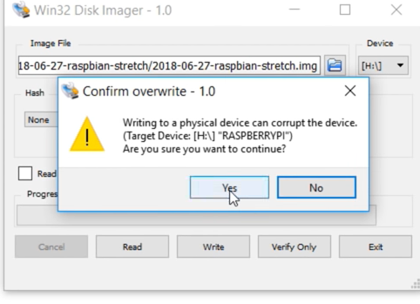

**Fig 1.6 –** Granting Win32 Disk Imager Permission.

Granting Permission in VNC viewer to access raspberry pi screen on laptop

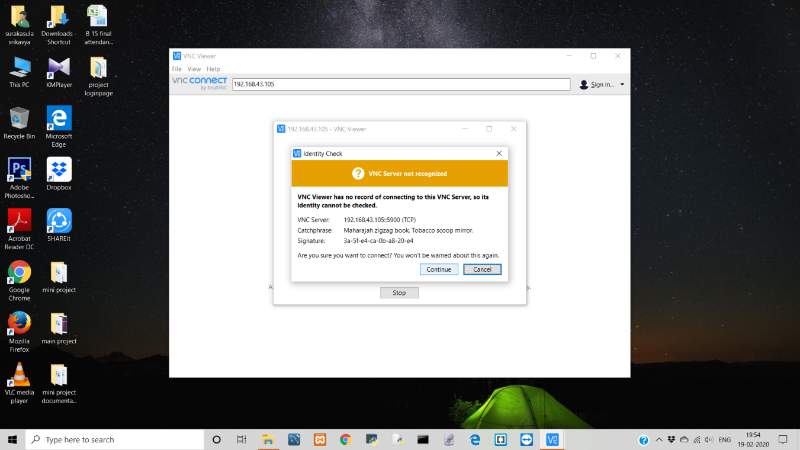

**Fig 1.6.1 –** Granting VNC viewer Permission.

Enabling VNC to access raspberry pi screen

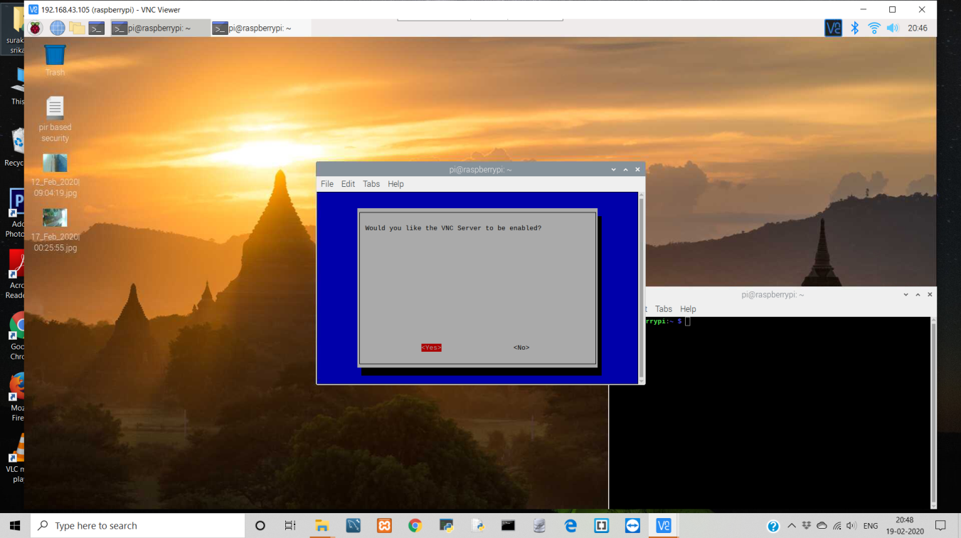

**Fig 1.6.2 –** Enabling VNC.

1. **LITERATURE REVIEW**

**In the year 2018, Kiran Kumar.R** has developed a "Face Recognition attendance system using Raspberry Pi" which is used for the purpose of recognizing the face of a person who faces the Pi camera module attached to the Raspberry Pi. The Raspberry Pi also has the Raspbian OS installed which is connected to a SQL database. The images captured by the camera are matched and compared with the images stored in the database. This way the face gets recognized by the system.

**In August 2019, Purnima Prakas and T.J Nagalakshmi** have developed a system called  "Fast and Economical Object Tracking using Raspberry Pi 3.0". This is a system which is used for the detection of objects. In this system, a Kernel Correlation Filter (KCF) tracking algorithm has been used and this was implemented with the help of OpenCV 4.0 version. There is a Pi camera attached to the Raspberry Pi and this captures the pictures of the objects that are to be detected. This is how an object tracking system had been developed with a Raspberry Pi, Pi camera and a KCF tracker

Human detection has several applications in security systems. In this work, a security system is implemented using human detection technology; the process is done without any human intervention. In the system a Raspberry Pi installed with Geanny, Thonny library and a Raspberry Pi Camera module is connected for human detection. The data will be stored in the memory card which is connected to the Raspberry Pi and it willbe accessed through the internet. The results show that increases the accuracy.

Human Detection is an security based application. The optimized security system which restricts the entry of unknown. There were so many new technical instruments but the security was still the question of matter. So to improve the existing security and reduce the risks we come with this project. The basic work structure of the human detection system is: - If there is a human passing by, the camera captures the image. After this, a security alert will be sent to the authorized person who contains the captured images.

1. **PROBLEM IDENTIFICATION & OBJECTIVES**

**Abnormal event detection**

The most common application of human detection in video surveillance is to detect an abnormal event beforehand. These events can be categorized into single-person loitering, multiple- person interactions (e.g. fighting and personal attacks), person-vehicle interactions (e.g. vehicle vandalism), and person-facility/location interactions (e.g. objectsleft behind and trespassing).

**Person detection in dense crowds and people counting**

Detecting and counting persons in an exceedingly dense crowd is challenging because of occlusions. Eshel and Moses used multiple height homographies for head top detection to beat this problem. Yao and Odobez proposed to take advantage of the stationary cameras to perform background subtraction and jointly learn the looks and therefore the foreground shape of individuals in videos. Simet al developed a representation called the colorur bin image which is extracted from the initially detected windows, and they use it for training a classifier to enhance the performance of the initial detector. The proposed system was used for detecting individual heads in dense crowds of 30 to 40 people against cluttered backgrounds from one video frame. However, the performance of their approach cans also bechallenged by the colour intensities of the heads to be detected.

**Person tracking and identification**

An individualin a video surveillance system can be recognized using face detection and gait recognition techniques. The detection and tracking of peoplein crowds at public places is difficult because of a partial or full occlusion problem that may be for a short or long period of time. Leibe et al tried to address this issue using trajectory estimation while Andriluka et alused a tracklet-based detector, which was able to detect many partially occluded people that cannot be identified in one frame alone. Yilmaz et al comprehensively surveyed on tracking methods and divided them based on the object and motion representations used. The wider use of human detection is not only restricted to analyze surveillance videos but also to extend player tracking and identification in sport videos.

1. **SYSTEM METHODOLOGY**

A Memory Card (16GB) is chosen to install the software required to start the process of the project. Initially the Memory card is formatted then Raspbian Noobs lite software is installed. Then Memory Card is inserted into Raspberry Pi then, Python Integrated Development Environment like Geanny and Thonny is installed and VNC Viewer is set.

**4.1** **Software Requirements**

Geany.

Thonny.

**4.1.2 Database Management Systems:** Raspberry Pi has Internal Database and external storage slot.

**4.2 IoT Components:**

Raspberry Pi – Version 3 Model-B.

PIR sensor.

Buzzer.

Raspberry Pi Camera.

**4.3 Non Functional Requirements**

**Processor:** i3 7th generation.

**Memory requirement:** 500GB.

**RAM:** 4GB.

**4.4 Win32 Disk Imager Installation (Formatting SD Card)**

Visit https://sourceforge.net/projects/win32diskimager to download Win32 Disk Manger and follow the steps and format the SD card.

Memory card formatting is the process in which a flash memory device is prepared for data storage. It remove the previously existing data and information written on the card ("low level formatting") and creates a new file system ("high level formatting"). Hence the Secure Digital (SD, SDHC, and SDXC) card will be cleaned.

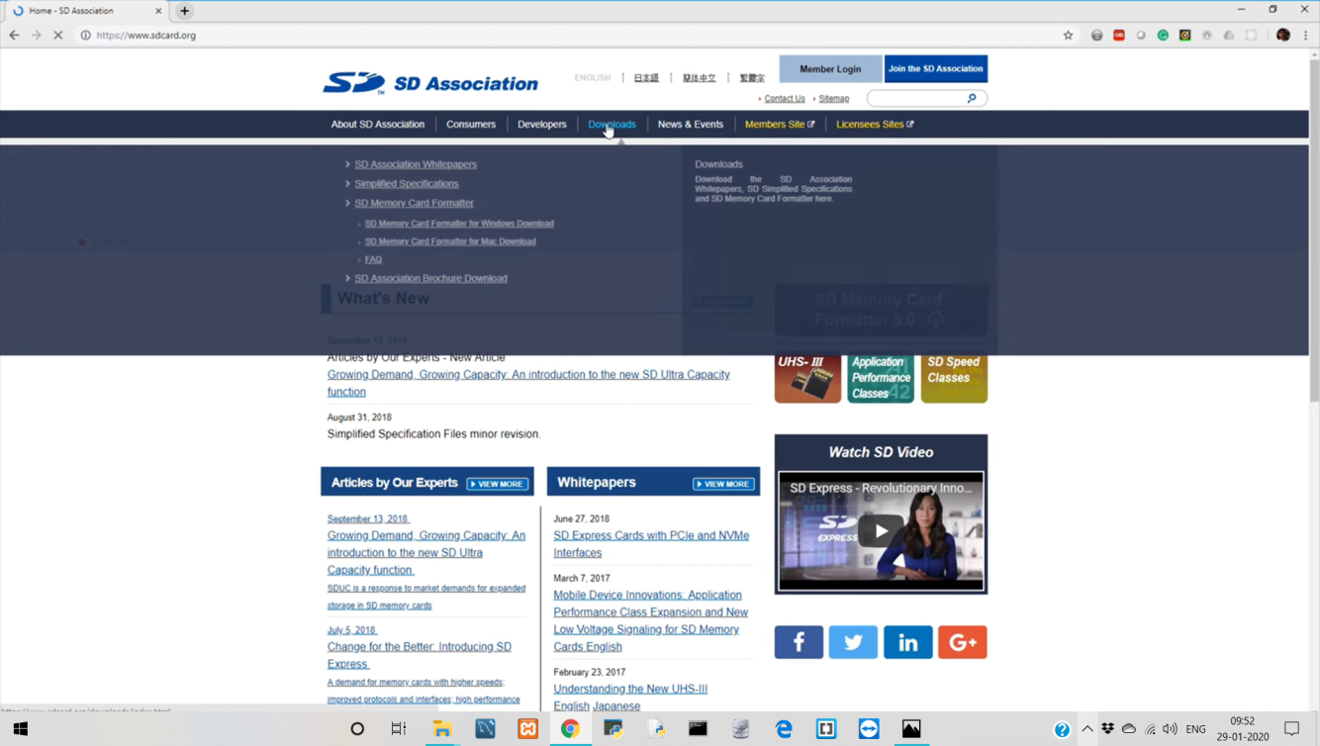

**Fig 4.4 –** Visit Win32 Disk Imager Site.

Once the site is visited go to downloads and download SD Memory Card Formatter For Windows as shown in Fig 4.4.1.

Then allow SD Card Formatter to make changes on your device as shown in Fig 4.4.2.

The installing process starts as shown in Fig 4.4.3.

Accept the license agreement as shown in Fig 4.4.4.

Once Installation is finished as shown in Fig 4.4.5. A Pop-Up Window will be opened for locating Wine32 Disk Manager Then correctly Chose the path of memory card which we are going insert in Raspberry pi as shown in Fig 4.4.6.one this entire process is done memory card is formatted successfully as shown in Fig 4.4.7.



**Fig 4.4.1 –** Download Page of Win32 Disk Imager Site.

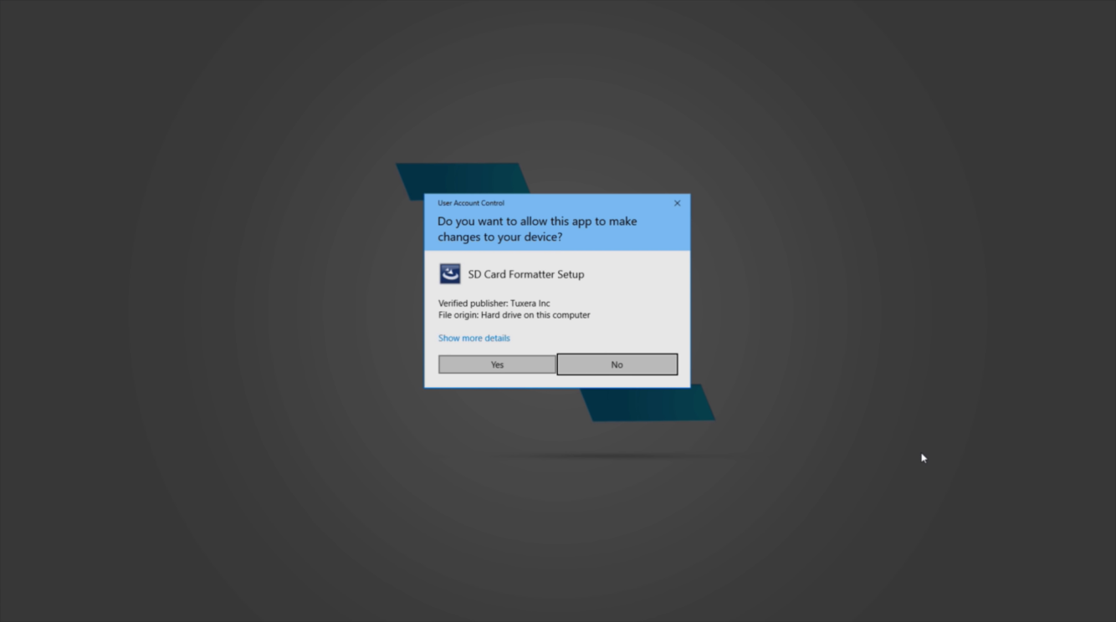

**Fig 4.4.2 –** SD Card Formatter Pop-Up Window

.

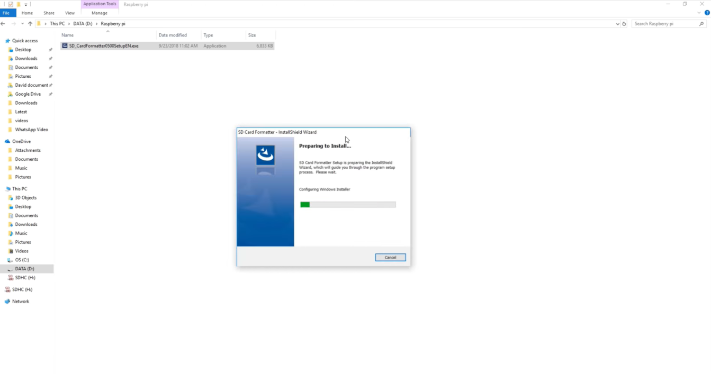

**Fig 4.4.3 –** Installing Process**.**

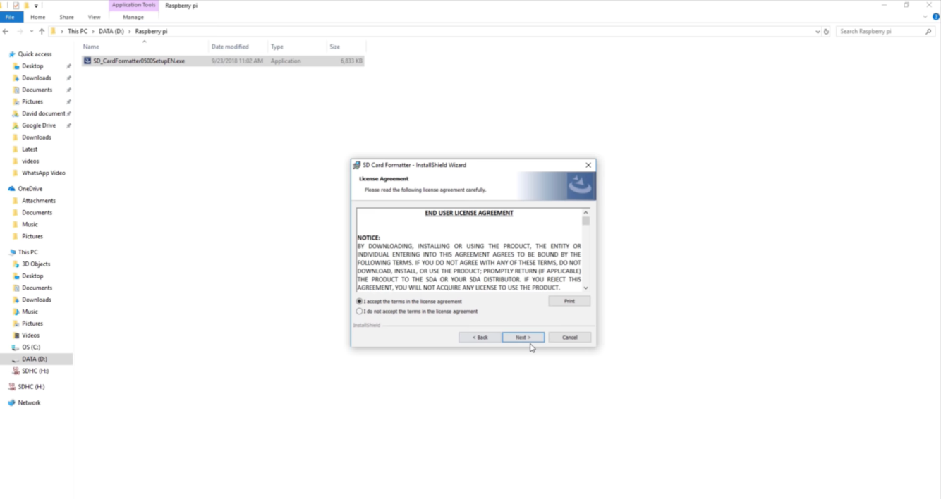

**Fig 4.4.4 –** License Agreement.

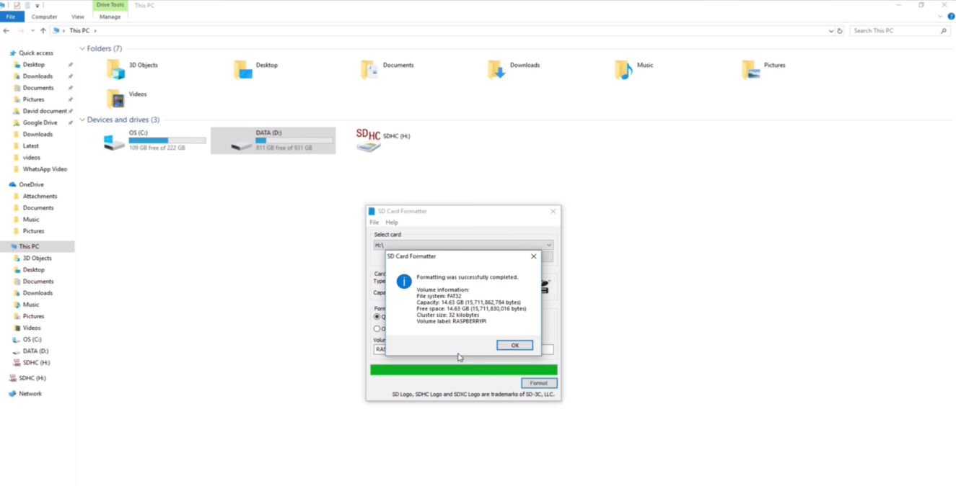

**Fig 4.4.5 –** Installation Finished.



**Fig 4.4.6 –** Path Setting In Memory Card.

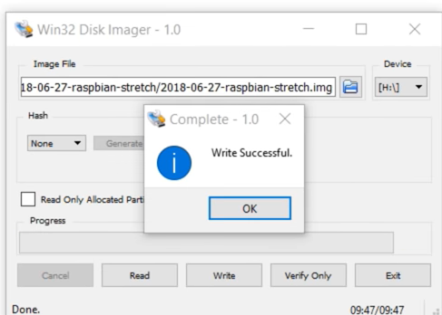

**Fig 4.4.7 –** SD Card Formatted Successfully.

**4.5 Installation Of Raspiban Noobs lite (On SD Card)**

Visit <https://www.raspberrypi.org/downloads/>to download Raspbian Noobs and follow the below steps:

Visit the site as shown in Fig 4.5.

Once the site is visited there will be two Torrent files one is Noobs and other is Noobs lite both process is same but we opt Noobe lite even if you for Noobs there is no issue then, install Noobs lite as shown in Fig 4.5.1.

Once the Zip file of Noobs lite is downloaded set the path to memory card which is to be inserted in raspberry pi as shown in Fig 4.5.2.

Finally, extract the files as shown in Fig 4.5.3.

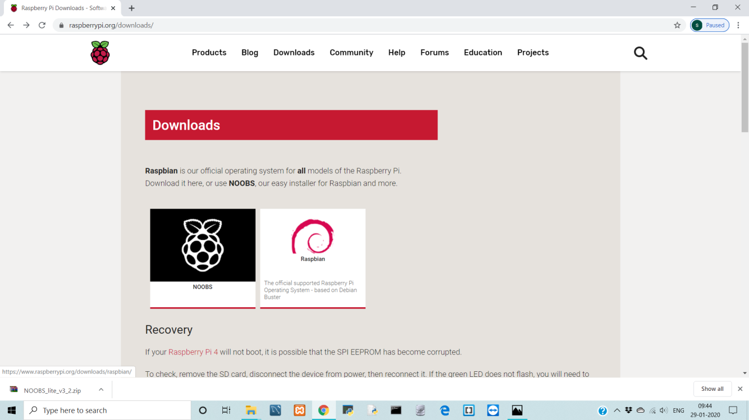

**Fig 4.5 –** Visit Raspberry Pi Software Site.

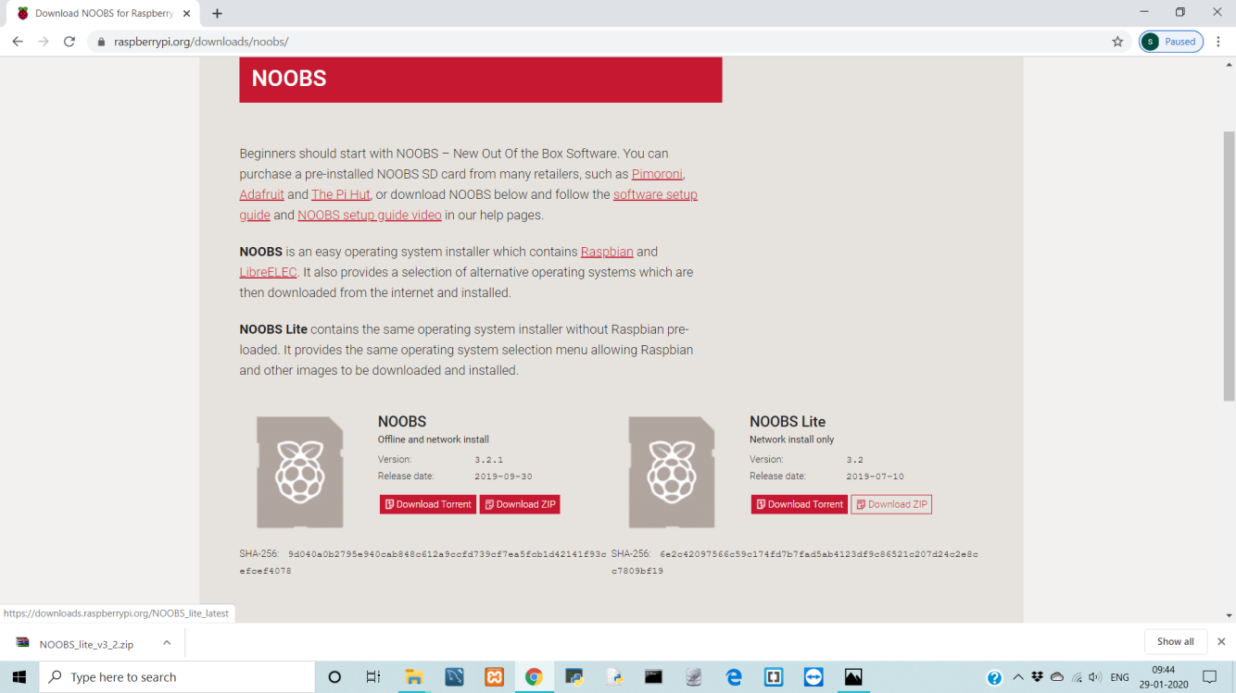

**Fig 4.5.1 –** Noobs lite Zip File is installed.

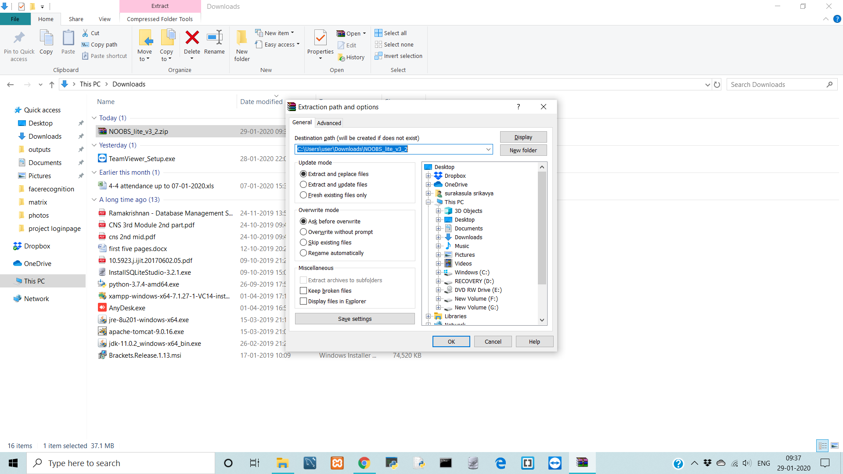

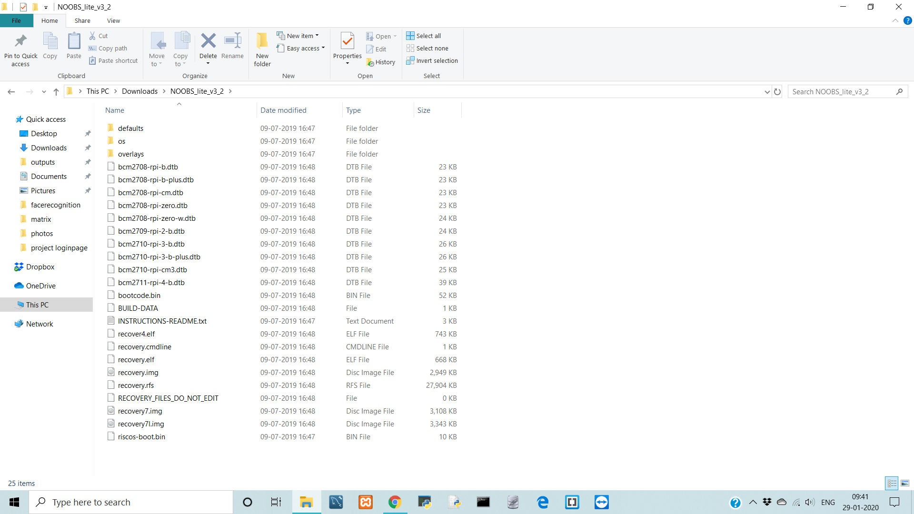**Fig 4.5.2 –** Setting Location.

**Fig 4.5.3 –** Extract Files.

* Installation of Win32 Disk Imager and Raspberry Pi software is done memory card can be inserted in Raspberry Pi and through HDMI port connection the raspberry pi screen can be viewed on any source like TV screen, desktop screen.
  1. **Setup the Hotspot to Raspberry PI (On Raspberry Pi Screen)**

To install Integrated Development Environments and to setup VNC Initially Raspberry Pi requires Hotspot. Once Hotspot is connected the VNC in raspberry pi screen shows the IP address of the internet connected to raspberry Pi as shown:

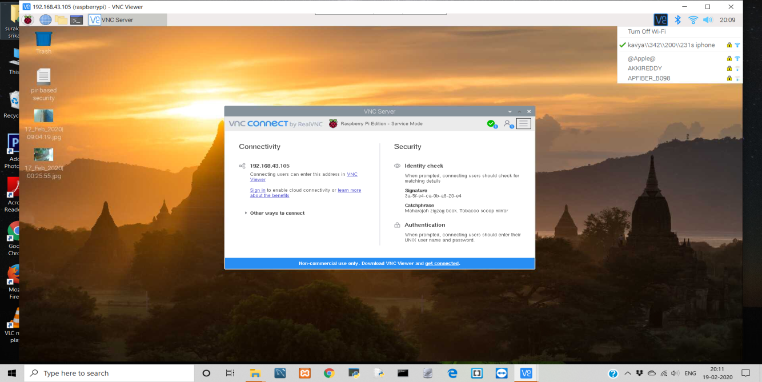

**Fig 4.6 –** Connecting Raspberry Pi to Internet.

**4.7 Installation of Integrated Development Environment (On Raspberry Pi Screen)**

Basically, Raspberry Pi has Python Editor of version 2.7 which is not latest. So, In addition to that two Integrated Development Environments Named Geany & Thonny were installed.

The installation Process is not so large as Win32 Disk Imager & Raspberry Pi Software. We just need to download them and Point them to Memory card location.

Visit The Site and Follow the steps To Install Geany in Raspberry Pi (Those steps need to be executed in command prompt of Raspberry Pi) <https://www.geany.org/download/third-party/>.

Visit The Site and Follow the steps To Install Thonny in Raspberry Pi (Those steps need to be executed in command prompt of Raspberry Pi) <https://thonny.org/>.

**4.8 Setting Up & Enabling VNC Viewer (On Raspberry Pi Screen)**

Installation of VNC on Raspberry Pi Screen by writing the following two command on raspberry pi prompt as shown below:

Command-1:

Sudo apt update

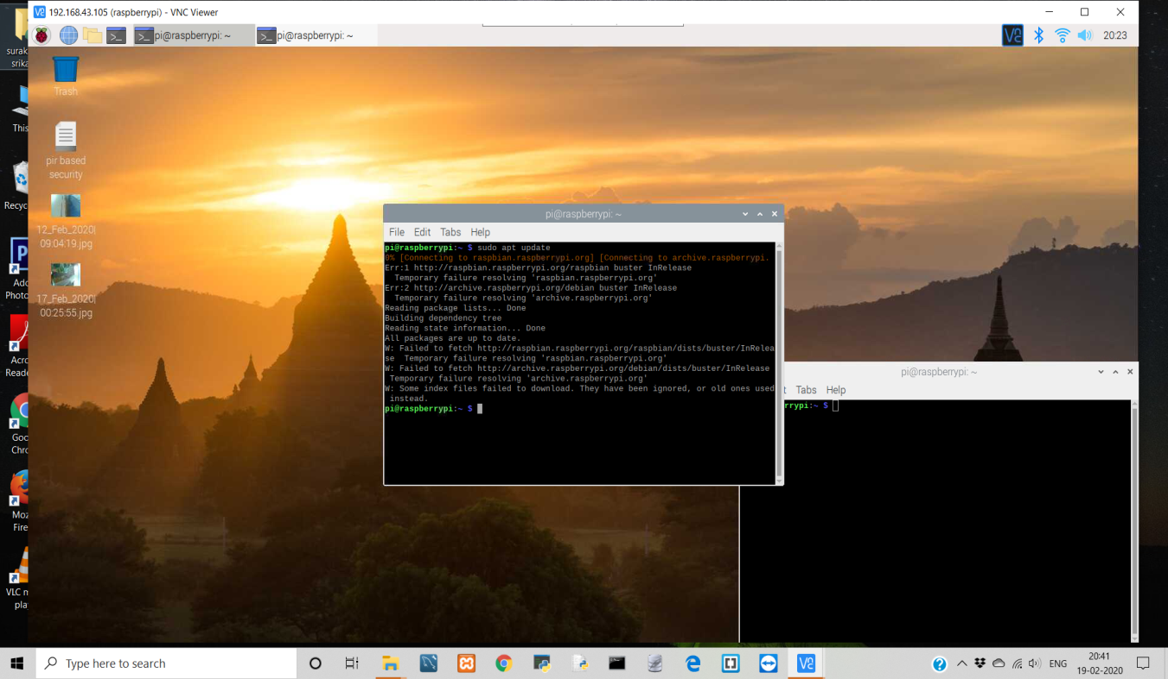

**Fig 4.8 –** VNC Installation Command-1.

Command-2:

Sudo apt install realvnc-vnc-serevr realvnc-vnc-viewer

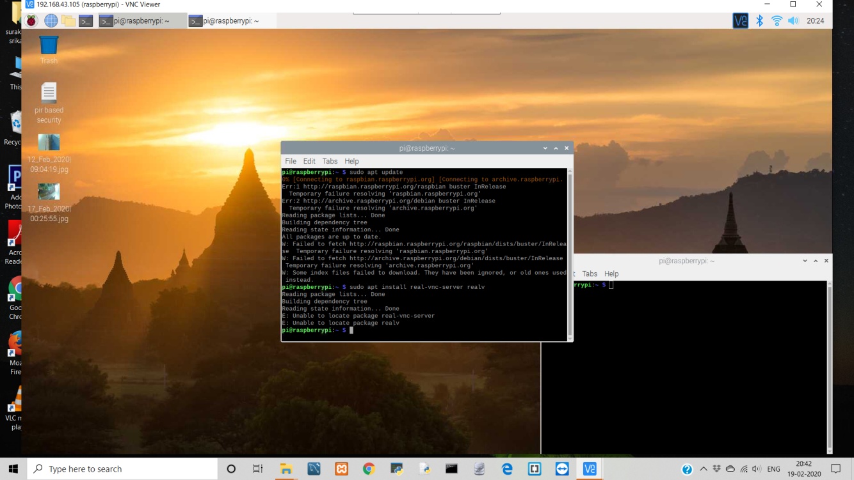

**Fig 4.8.1 –** VNC Installation Command-2.

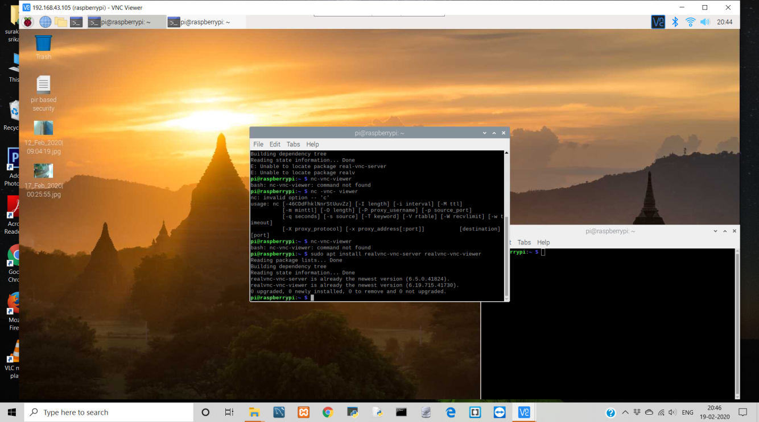

**Fig 4.8.2 –** VNC Installation Of Commands.

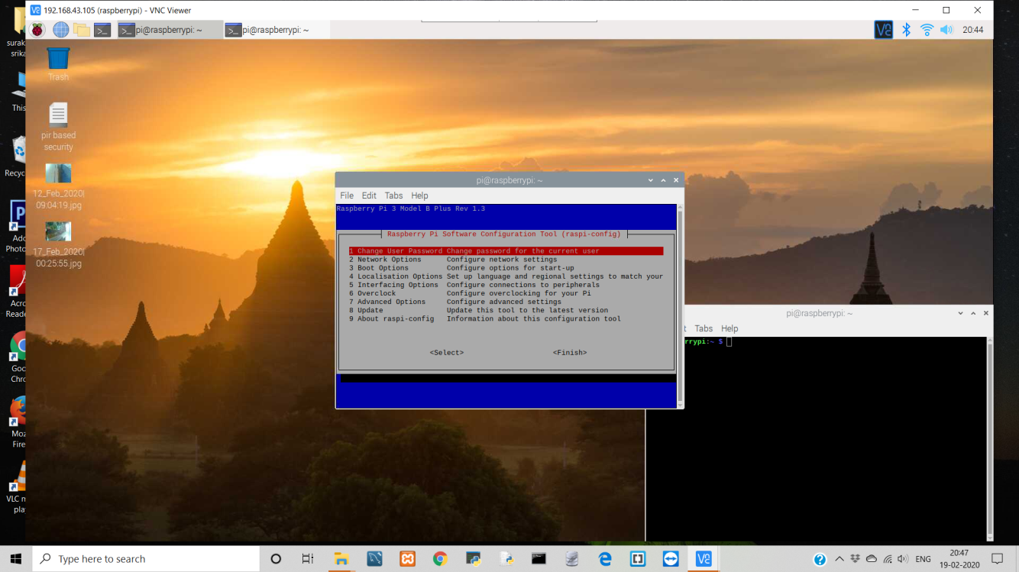

**Fig 4.8.3 –** VNC Interface Setting.

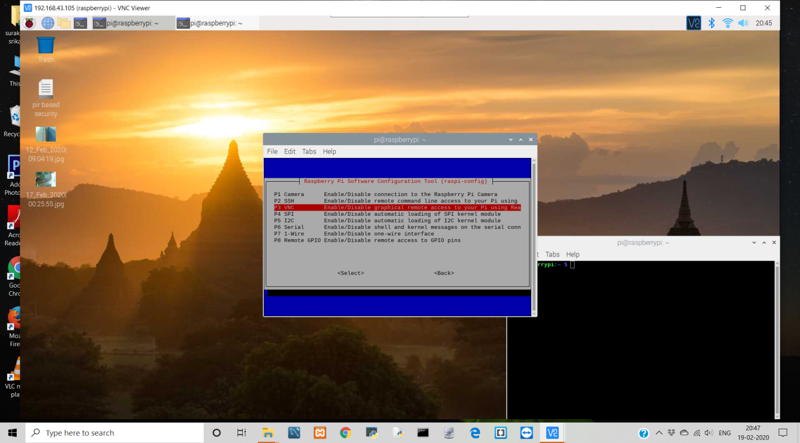

**Fig 4.8.4 –** Enabling VNC.

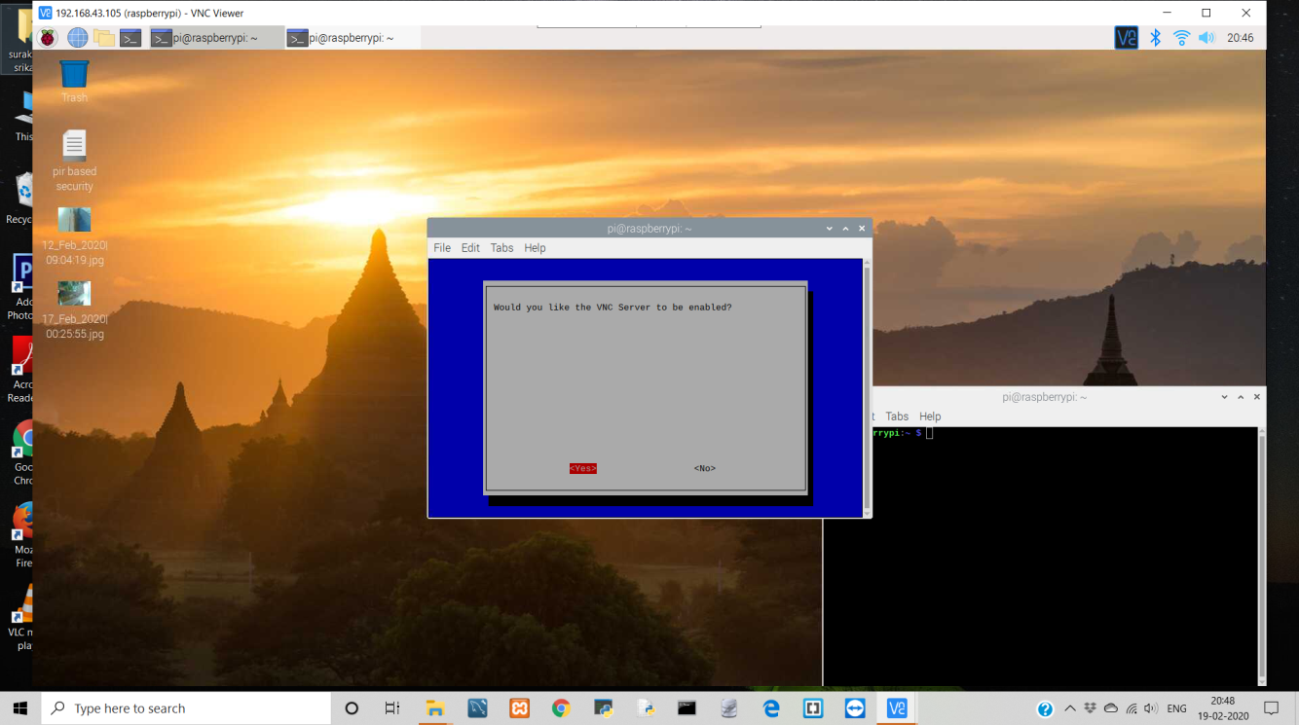

**Fig 4.8.5 –** Enabled VNC.

* 1. **Connecting VNC Viewer (On Laptop Screen)**

The IP address that is obtained as shown in 2.3 will be entered in VNC viewer that is installed in laptop. By this we can access Raspberry Pi screen from laptop Instead of LCD display of TV or Desktop screen as shown below:

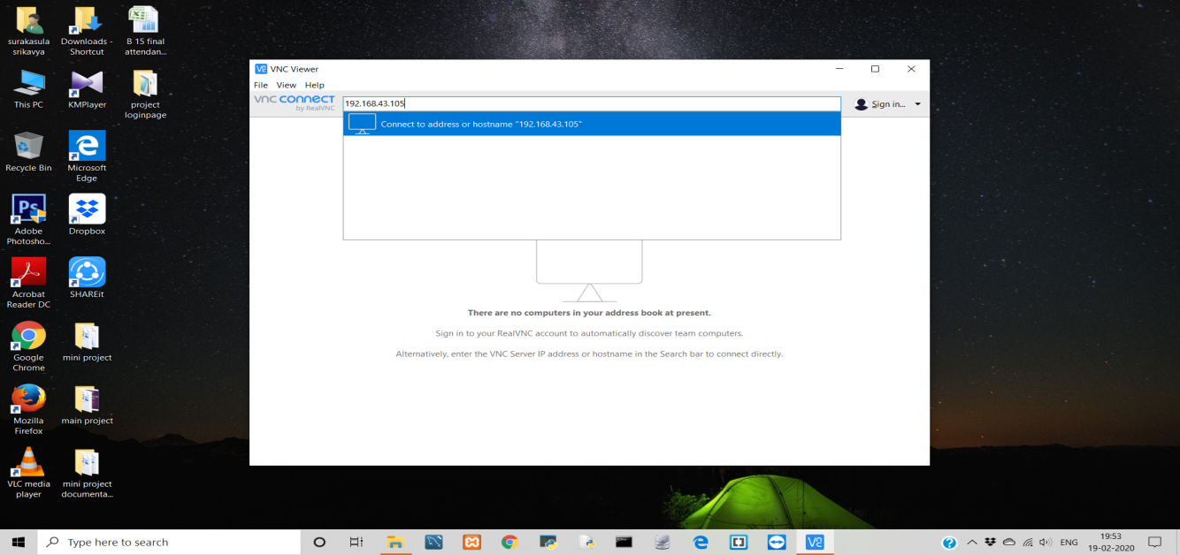

**Fig 4.9 –** Connecting to VNC Viewer on Laptop Through IP address.

Once IP address is entered in Laptop a Pop-Up window will come by asking username and password to access raspberry pi (the user name and password are created while importing packages in the code. They can’t be changed once they are created) as shown :

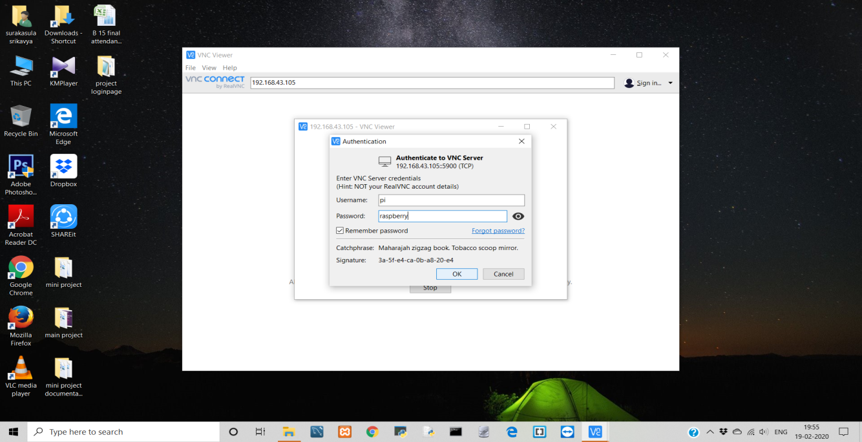

**Fig 4.9.1 –** Connecting VNC Viewer to Raspberry Pi.

Now, Grant the permissions to access the raspberry pi through laptop screen. as shown below:

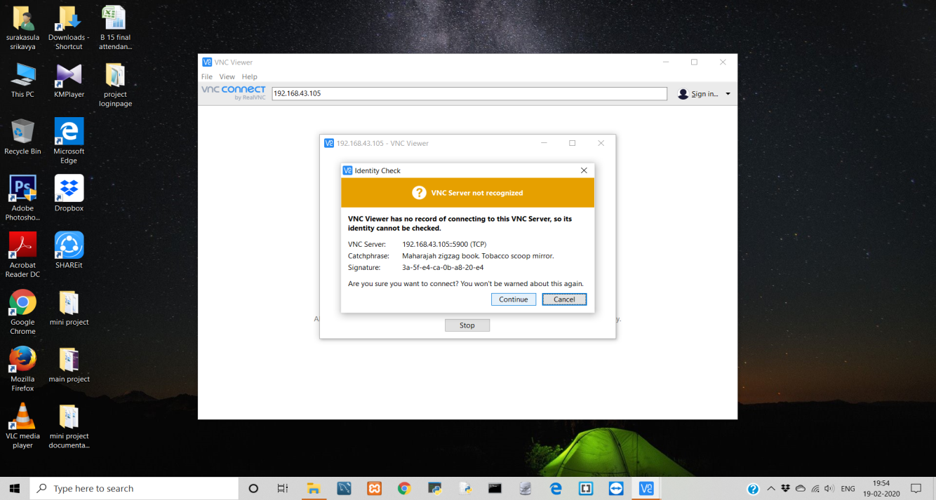

**Fig 4.9.2 –** Grant the permissions.

Finally, The view of Raspberry Pi Screen on laptop as shown below:

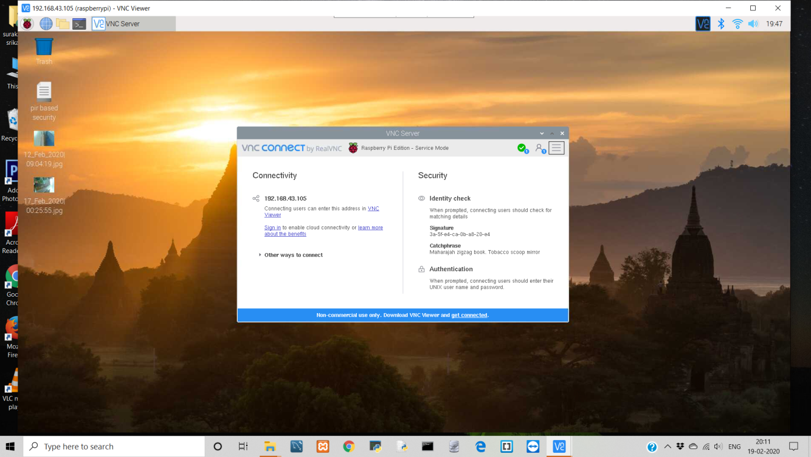

**Fig 4.9.3 –** View of raspberry pi screen on laptop.

As Mentioned Raspberry Pi is a mini computer we can browse the things as required. Instead of writing code in raspberry pi screen we wrote the code on Integrated Development Environment (which is their in laptop) and downloaded that file in raspberry pi screen using Mail (with the help of browser option on raspberry pi) as shown below:

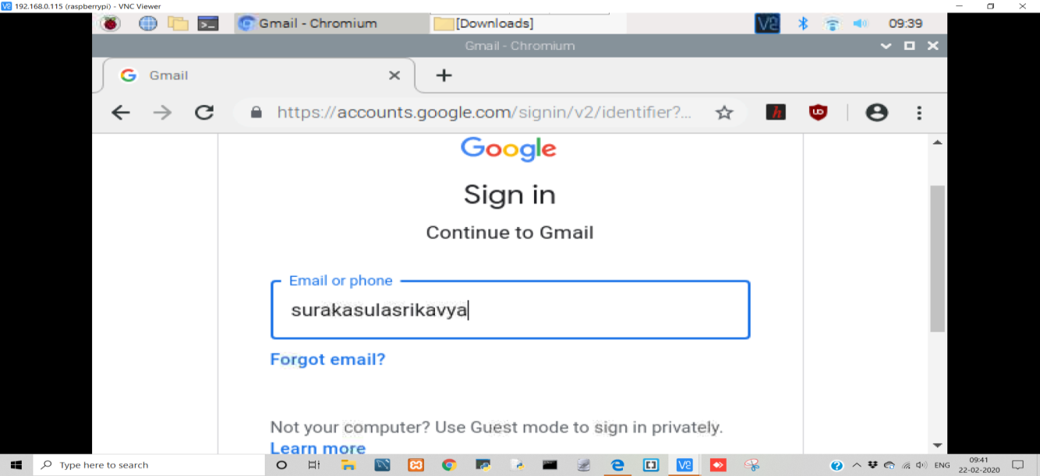

**Fig 4.9.4 –** Browser View of Raspberry Pi.

**Mail login view in raspberry Pi as below:**

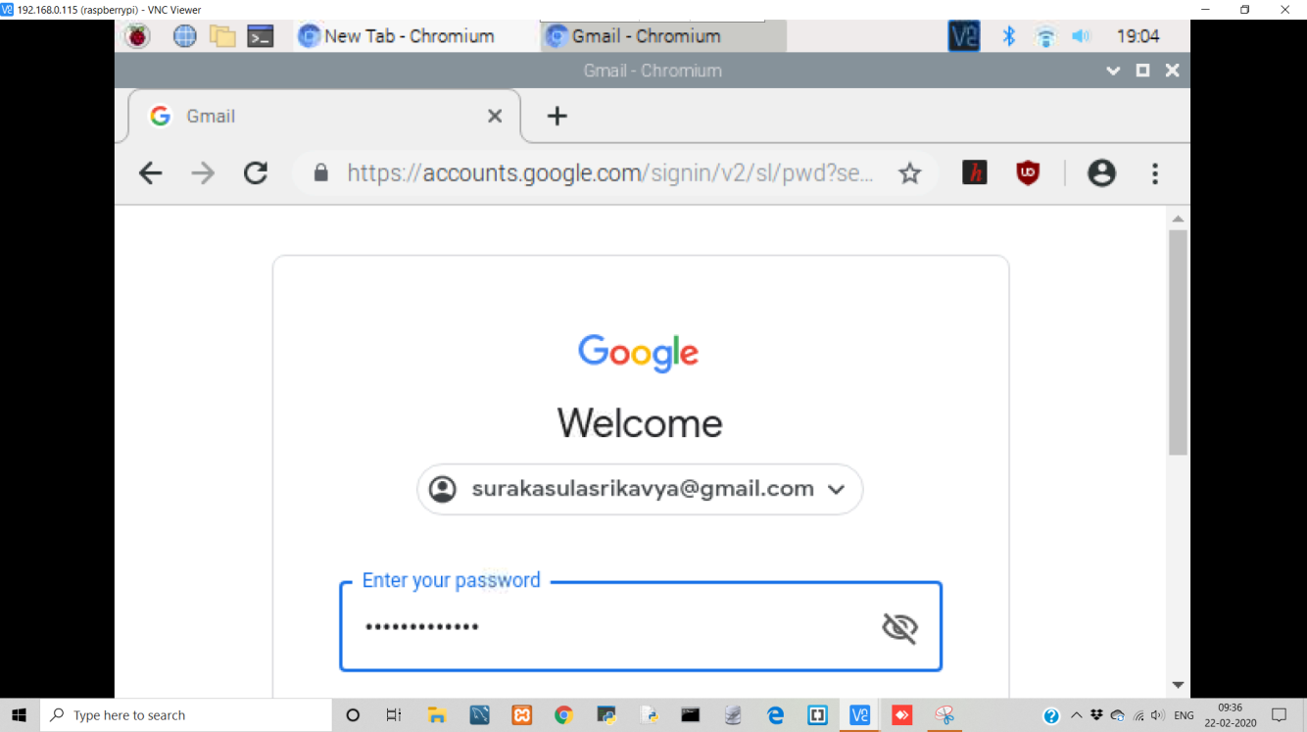

**Fig 4.9.5 –** View of Mail on Raspberry Pi

#### Features of Raspberry PI Version 3 Model-B

* A SD card slot.
* Broadcom Quad CPU 64-bit.
* HDMI video output/ VGA cable port.
* Power Cable connector.
* Four USB ports for connecting devices like mouse, keyboard.
* Forty extended GPIO pins.
* LAN and Ethernet cables.

1. **OVERVIEW OF TECHNOLOGIES**

System Analysis is where the importance is given to understand the details of an existing system or a proposed system and then to decide the proposed system is desirable or not and if the existing system requires any improvements.

**5.1 Existing System**

**OpenCV-**

OpenCV is an open source computer vision and machine learning software library. OpenCV was built to provide a common infrastructure for computer vision applications and to accelerate the use of machine perception in the commercial products. This makes it easy for us to utilize and modify the code.

**Python Versions-**

Python 3.7.4 is the second release candidate preview of the fourth maintenance release of Python 3.7. The Python 3.7 versionis the latest main release of the Python language and it consists of several new features and optimizations.

**Application Working-**

Webcam capture the live image , it consider the captured BGR image as input and converts the BGR image to GRAY scale image and internally consider the recognized face as array then, compare this value with the sensor value that are pre-defined in the haarcascade_frontalface_default.xml. If the values are matched a rectangle red color box will appear around the identified human face.

**Algorithm Used-**

The concept behind AdaBoost is to set the weights of classifiers and training the data sample in each iteration such that it ensures the accurate predictions of unusual observations. Any machine learning algorithm can be used as base classifier if it accepts weights on the training set.

AdaBoost algorithm can be used to boost the performance of any machine learning algorithm. Machine Learning has become a powerful tool which can make predictions

based on a large amount of data. It has become so popular in recent times that the application of machine learning can be found in our day to day activities.

To recognize the human face a Haarcascade file is used that is generated using AdaBoost Algorithm in machine learning.

**Haarcascade File-**

The Haar Cascade is trained by superimposing the positive image over a set of negative images. The training is generally done on a server and on various stages. Better results are obtained by using high quality images and increasing the amount of stages for which the classifier is trained.

In machine learning, boosting originated from the question of whether a set of weak classifiers could be converted to a strong classifier. Weak learner or classifier is a learner which is better than random guessing and this will be robust in over-fitting as in a large set of weak classifiers, each weak classifier being better than random. As a weak classifier, a simple threshold on a single feature is generally used. If the feature is above the threshold than predicted, it belongs to positive otherwise belongs to negative.

AdaBoost stands for ‘Adaptive Boosting’ which transforms weak learners or predictors to strong predictors in order to solve problems of classification.

The code in Haarcascade file will be in the form of extensible markup language that is tree structure. The tree contain many words where each node has sensor values as described below-

* The file contains only parameters defining the decisions criteria of the weak classifiers created by the boosting process.
* Stage and the Classifier check the image with Feature 1 and if the Value is bigger/ smaller as the Feature Threshold the first/ second LeafValue is added to the StageValue. After all Features of the stage the StageValue is compared with the stagethreshold and decided if the stage is passed or not.
* <MaxWeakCount>3</maxWeakCount>  
  this parameter describe amount of simple classifiers (trees) at the stage.
* <Stagethreshold>3.5069230198860168e-01</stagethreshold>  
  It is stage threshold, i. e. threshold score for exiting from cascade at the stage. During all stages, we compute final score from trees, and when final score is less then threshold, we exit from entire cascade and consider result as non-object.
* <WeakClassifiers> start of the tress parameter in the stage.
* <_>  
   <internalNodes>  
      0 1 0 4.3272329494357109e-03 -1 -2 1 1.3076160103082657e-02  
   </internalNodes>  
   <leafValues>  
      3.8381900638341904e-02 8.9652568101882935e-01 2.6293140649795532e-01  
   </leafValues>  
  </_>  
  this is tree description. InternalNodesparameter contains the following:   
    
  a. 0 1 or 1 0 defines leaf index in current node where we should go. In a first case we go to the left if value is below threshold and to the right if above, and in a second case we go to the right leaf if value is above threshold.  
    
  b. there is one more -1 -2 1 ... parameters list - as I see from OpenCV sources, it is just another node with leaf indexes, but negative values are ignored according to evaluation code
* <_>  
  <rects>  
   <_>  
  6 3 9 -1. <_>

<_>

6 6 1 3 3. <_>

</rects>

<_> <_>

**a**. It is feature description. It contains the indexes for feature description.

**b**. leafValues contains left value (i. e. left leaf score), right value (right leaf score) and tree threshold.

**5.2 Proposed System**

IoT Components are used in the system that we proposed to develop. The components used are as follows:

**Raspberry Pi-**

Raspberry Pi acts a minicomputer whose display can be viewed on Desktop screen/TV screen/Laptop screen with the help of cables like VGA and HDMI video output cables. As well Raspberry Pi has forty extended GPIO pins which are used to process the application. For additional input and output devices connection the Raspberry Pi has four USB ports. Raspberry Pi has many components like LAN port, Ethernet controller, Broadcom quad CPU, SD card slot.

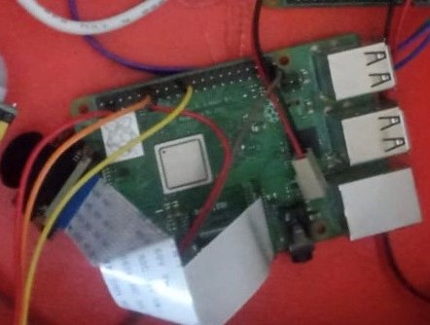

**Fig 5.2.1 –** Raspberry Pi Version 3 Model-B Image.

Raspberry Pi acts a minicomputer whose display can be viewed on Desktop screen/TV screen/Laptop screen with the help of cables like VGA and HDMI video output cables. As well Raspberry Pi has forty extended GPIO pins which are used to process the application. For additional input and output devices connection the Raspberry Pi has four USB ports. Raspberry Pi has many components like LAN port, Ethernet controller, Broadcom quad CPU, SD card slot.

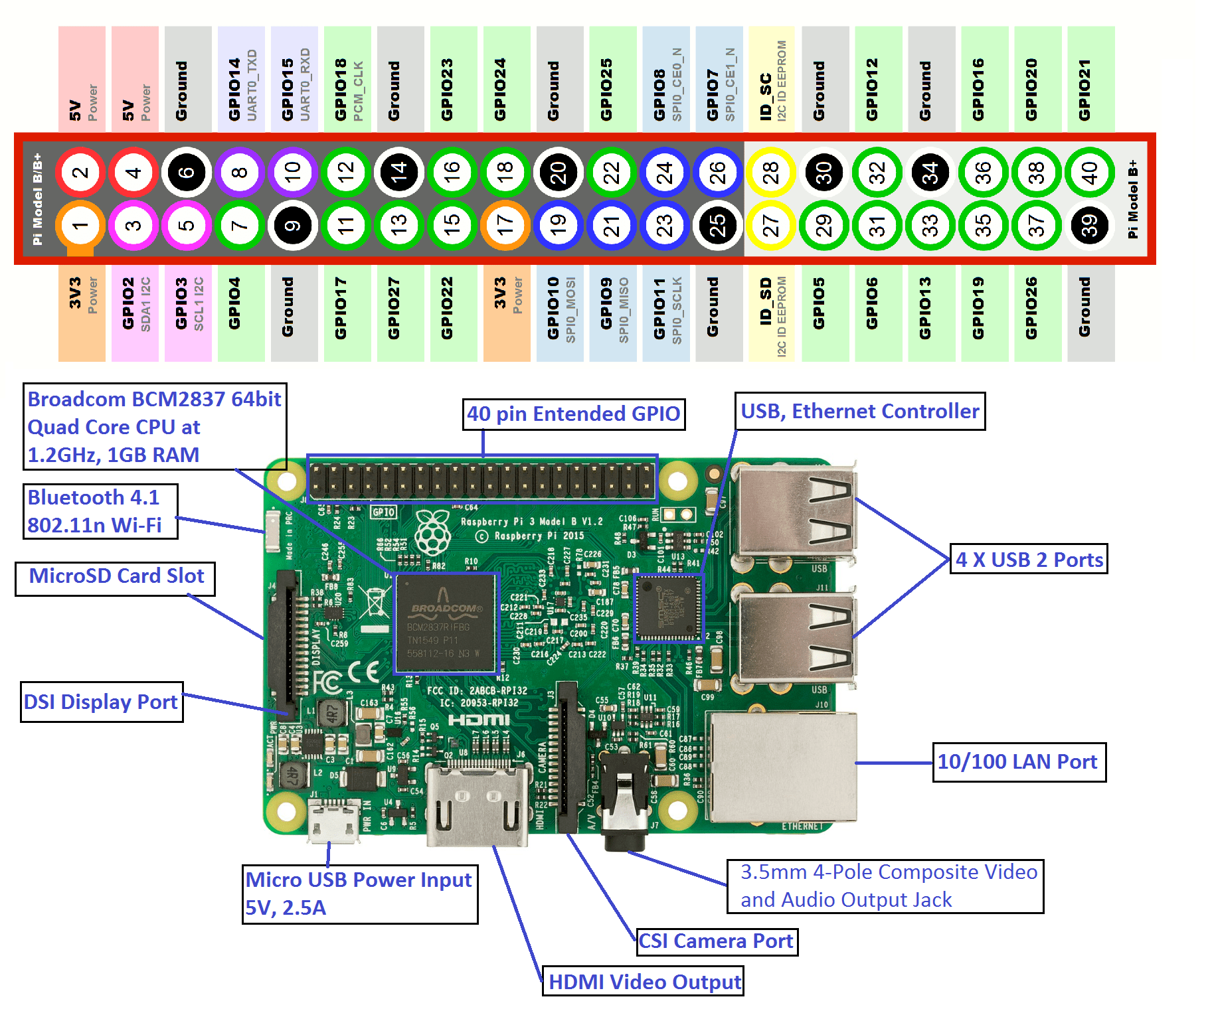

**Fig 5.2.2 –** Raspberry Pi Pin Diagram.

**PIR Sensor-**

A PyroElectric Sensor (PIR) is used to detect the human with the help of infra red rays that is emitted from the human body. It can detect the human with specific range as here in the project the basic PIR sensor is used which detects human that range 3m. this PIR Sensor has three pins one is ground (GND), voltage common convertor (VCC) and the other pin is out (Gout) which helps PIR to operate when human is detected.

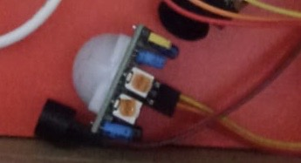

**Fig 5.2.3 –**  PIR Sensor.

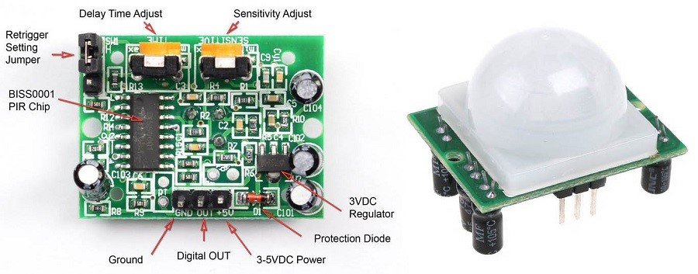

**Fig 5.2.4 –**  PIR Sensor Pin Diagram.

A PyroElectric Sensor (PIR) is used to detect the human with the help of infra red rays that is emitted from the human body. It can detect the human with specific range as here in the project the basic PIR sensor is used which detects human that range 3m. this PIR Sensor has three pins one is ground (GND), voltage common convertor (VCC) and the other pin is out (Gout) which helps PIR to operate when human is detected.

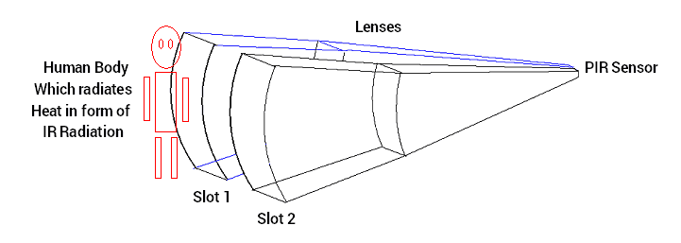

**Fig 5.2.5 –** PIR Sensor Working Principal.

**Passive Buzzer-**

A passive buzzer is used to indicate the human who passes through the restricted area with a buzzer beep sound. The buzzer has two pins one is ground (GND) and the other pin is out (Gout) which helps the buzzer to give an alert as the human is passed through PIR Sensor.



**Fig 5.2.6 –**  Passive Buzzer.

The image attached below is referred from the web

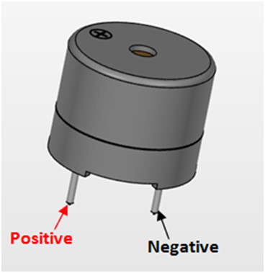

**Fig 5.2.7 –**  Passive Buzzer Pins.

As, This projects is regarding human detection a PIR Sensor is used because it capture the infra red waves from human body and detect human. If there is a Requirement/Need to provide security in high volume we can also replace PIR sensor with IR sensor which is used to detect the object whenever an object passes through IR sensor it detect the object and send alert.

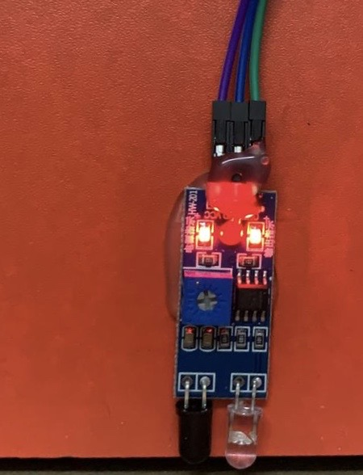

**Fig 5.2.8 –**  IR Sensor.

The basic concept of an Infrared Sensor which is used as Obstacle detector is to transmit an infrared signal, this infrared signal bounces from the surface of an object and the signal is received at the infrared receiver. The image attached below is referred from the web

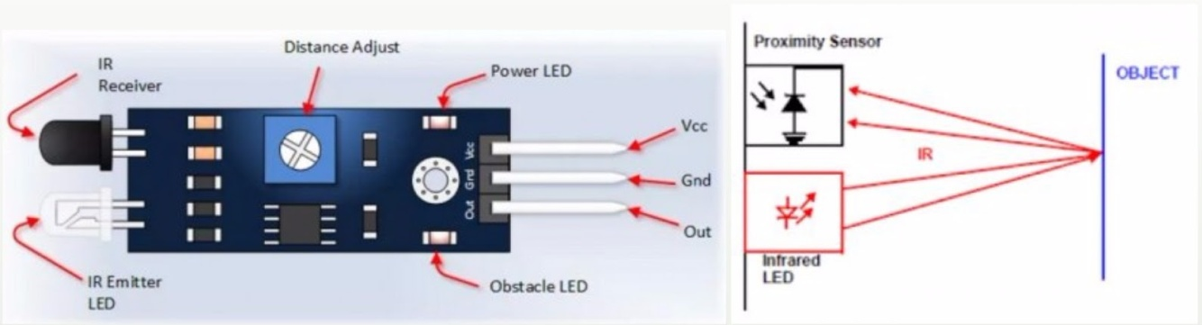

**Fig 5.2.9 –**  IR Sensor Working Principal.

**Raspberry Pi Camera-**

The raspberry pi we use has an in-built camera that is connected to the device through the ribbon cable. It is used to capture the image when human is detected by PIR.

Either we use PIR/IR to detect Human/Objectas per this project the detected Human/Object is to capture or the captured image is sent to mail. So, we require a camera here raspberry pi has attached camera as shown:



**Fig 5.2.10 –**  Raspberry Pi Camera.

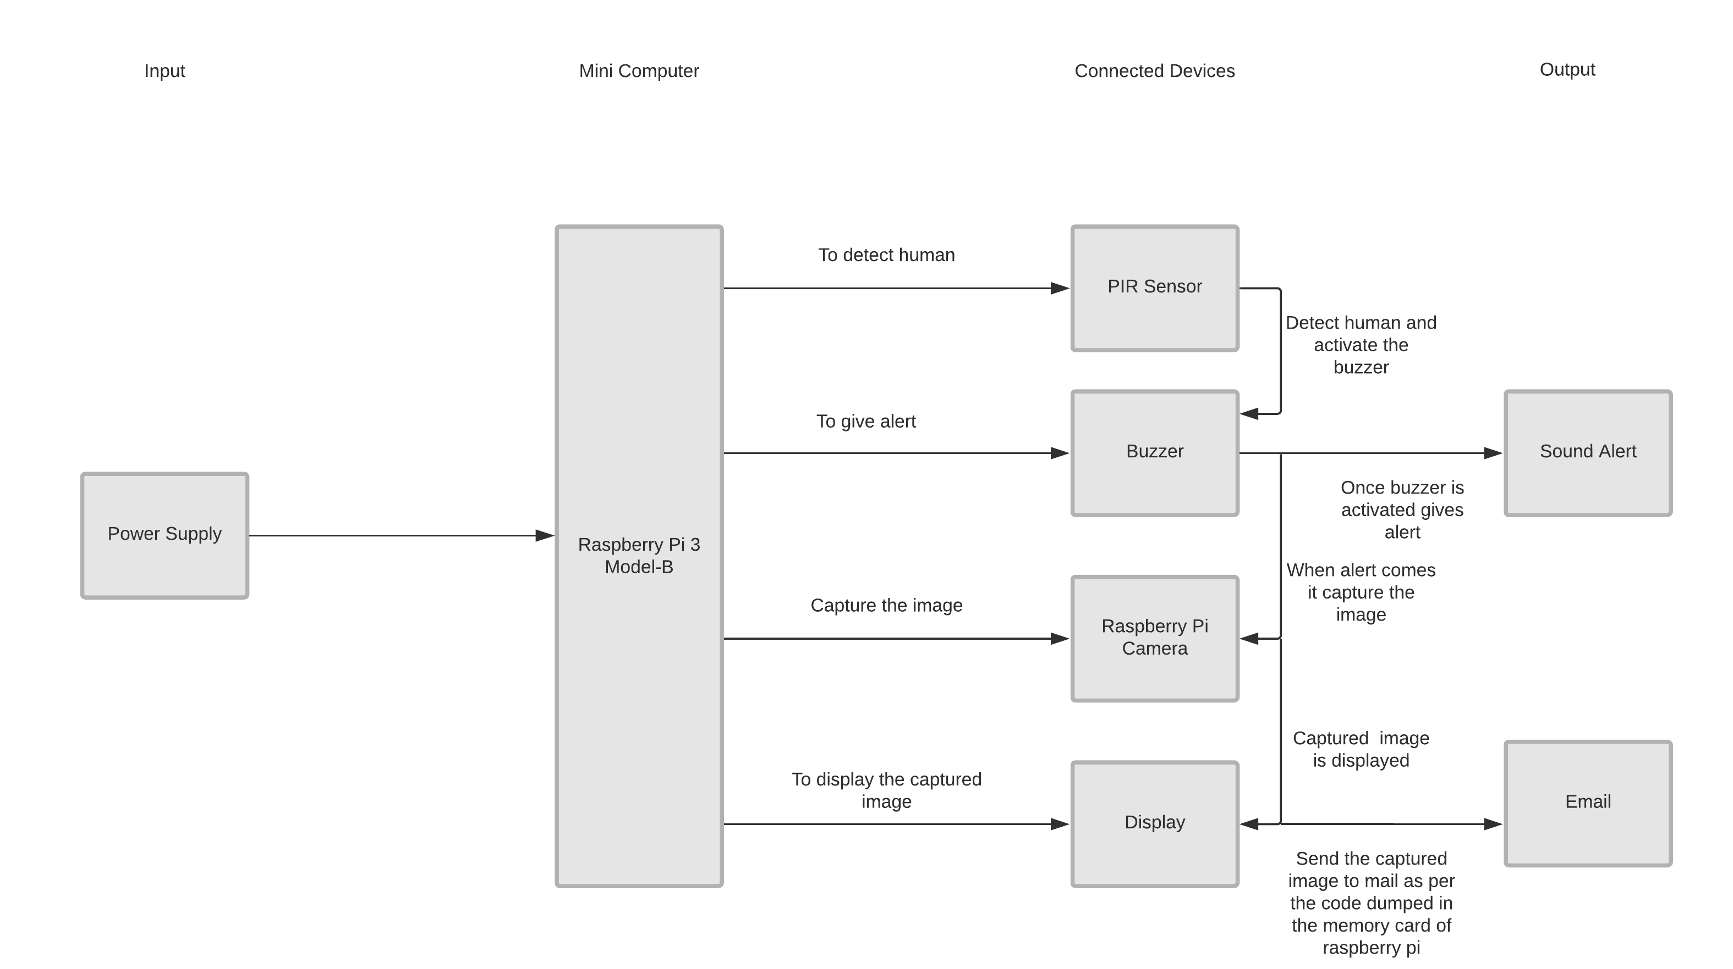

**Fig 5.2.11 –** Block Diagram.

**Working Principal:**

**Raspberry Pi-**

The Raspberry pi is a single computer board that can be used for many tasks that your computer does, like games, word processing, spreadsheets and also to play HD video.

Initially, we connect all the required devices to the raspberry pi. The connected devices are PIR sensor, Buzzer, Raspberry pi camera (In-Built), additional connections to handle the raspberry pi screen are mouse and keyboard.

**PIR Sensor-**

A PIR sensor detects the infrared light radiated by a warm object. It consists of pyro electric sensors which introduce changes in their temperature (due to incident infrared radiation) into electric signal. When infrared light strikes a crystal, it generates an electrical charge. The PIR sensor that we use in this project detects a human being moving around within approximately 3m from the sensor.

**Passive Buzzer-**

A buzzer or beeper is an audio signaling device which is used in alarm devices, timers, and confirmation of user input such as a mouse click or keystroke or when certain condition is satisfied as per the user requirement. In our project we use buzzer when human is detected by PIR.

**Raspberry Pi Camera-**

The raspberry pi we use has an in-built camera that is connected to the device through the ribbon cable. It is used to capture the image when human is detected by PIR.

**Display-**

The raspberry pi screen can be viewed by using HDMI cable for laptop screen/TV screen and VGA cable for desktop screen. Raspberry pi screen resembles a computer screen.

**SD – Card Inserted in Raspberry Pi-**

The code is dumped into the Raspberry pi using a SD card. We used a 16GB memory card for this purpose. To access the applications of Raspberry pi through a SD card, we need Raspbian software (NOOBS) which should be installed in the memory card. After installation, to access the code that is dumped, we require an Integrated Development Environment. In raspberry pi there are in built python editor (python v2.7). In addition to this, we install Geany and Thonny in the memory card. Once these installations are finished, the memory card is ready to be inserted in the Raspberry pi. Then, the Raspberry pi will be ready for compilation of the code.

**Power Supply and integrated development Environment-**

Initially, 5V DC power is supplied to the Raspberry pi, and hence all the connected devices receive power from the Raspberry pi. As power supply is set up, raspberry pi screen is accessed (either through laptop/desktop or TV screen) with the help of HDMI/VGA cable. Once the screen is displayed, the internet set up is to be made. When raspberry pi starts accessing the internet, a folder named “pir security.py” is displayed on the screen. The “pir security.py” is opened through Integrated Development Environment (i.e. Geany/ Thonny).

**Execution-**

Here, we run the code and when the code gets compiled, the Raspberry pi command prompt is displayed. The PIR sensor will get activated and starts detecting humans (range up to 3 meters). When the PIR detects humans, two modes of outputs will be activated. The first mode of output is a sound alert from the buzzer. The second mode of output is

to send an image that has been captured by the Raspberry pi camera to the e-mail that has been mentioned in the code (which is dumped into the Raspberry pi through a SD card).

**E-Mail Protocol-**

Simple Mail Transfer Protocol (SMTP) is the standard protocol which is used to send emails across the Internet. This is a [communication protocol](https://en.wikipedia.org/wiki/Communication_protocol) for the transmission of [electronic mails.](https://en.wikipedia.org/wiki/Email)It is an application layer protocol. The users who need to send the e-mails will open a TCP connection on the client side to the SMTP server and then send the mail across the connection. The SMTP server will always be on listening mode. As soon as it listen a TCP connection opened by any client, a connection on that port will be initiated by the SMTP. After successful establishment of the TCP connection, the client process sends the mail immediately and the receiver receives the mail.

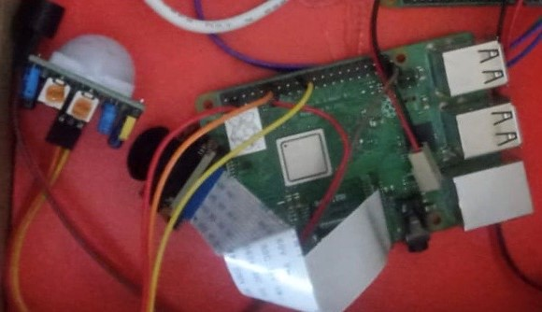

**Fig 5.2.12 –** Real-Time Application.

1. **IMPLEMENTATION**

The process in which defines the architecture, modules, interfaces and data for a system as per the specified user requirements is called as system design. System design could be seen as the application of system theory to development. There are some similarities with the principles of system analysis, system architecture and system engineering. If the border topic of product development “blends the perspective of marketing design, and manufacturing into a single approach to development,” then design is to take the marketing information and to createe the design of the product to be manufactured. Ttherefore the system is the process where we design and develop systems to satisfy specific user requirement. The increasing importance of the software in generic platforms has implied in increasing discipline of the software engineering.

**6.1 Logical Design**

The logical design of a system is related to a basic representation of the flow of data,system outputs and system inputs. This is often conducted via modeling using an over-abstract model of the original system.

**6.2 Physical Design**

The physical design relates to the original input process and output process of the system. This is explained in terms of how data is input into a system, howthe datais verified or authenticated, and how it is processed anddisplayed as an output. Physical design, here does not refer to tactile physical design of the devices and the system. To be clear, a personal computer’s physical design includes input through a keyboard, processing in the CPU, and output through a monitor, printer etc. It doesnot disturb the actual layout of the tactile hardware, which for a PC are: monitor, keyboard, CPU, motherboard, hard driveetc.

**6.3 UML Diagrams**

**6.3.1 Use Case Diagram**

The diagrams that are used to capture the system's function and user requirements in UML are called Use Case diagrams. Use-cases are the core ideas of Unified Modeling language modeling. The components of use case diagrams are use cases, persons, or several things that are imploring the features called actors and the elements that are liable for the implementation of the use cases. A live system’s dynamic behaviour can be captured by these diagrams. It models how an external item called entity communicates with the system to make it work. Use case diagrams are responsible for the visualisation of the external things/entities that interact with the part of the system.

Following are the common notations used in a use case diagram:

**Use-case:**

Use cases represent high-level functionalities and the system will be handled by the user. Representations like a distinct functionality of a system, a component, a package, or a class can be shown using a use case. It is represented by an oval shape and the name of the use case will be written inside the oval. The notation of a use case in UML is shown below:

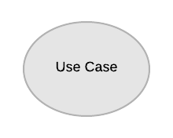

**Fig 6.3.1.1:** UseCaseName**.**

The Use Case Names that are used in our project are as follows:

* Pir Sensor.
* Raspberry Pi.
* Buzzer. Pi Camera.
* Display.
* Raspberry
* E-mail.

The six use case name here has its own the functionalities like Pir Sensor detect the human (detects the infrared light radiated by a warm object), Buzzer alerts with beep sound(when Pir Sensor detects huma n), Raspbery Pi which is a mini computer(it has slot for memory card in which the code is dumped, Pir as well, Buzzer is also connected to Raspberry Pi), Raspberry Pi camera captures the images(when both Pir and Buzzer are activated), Display may be of any kind which helps us to access the Raspberry Pi Screen like TV Screen/Laptop/Desktop which shows the image captured by Raspberry Pi Camera, E-mail is the source of output(the captured is sent to mail, the sender and receiver mails are dumped in the code).

**Actor:**

The actor is an entity that interacts and communicates with the system. The best example of an actor is a user. An actor is nothing butan entity that triggers the use case from outside the scope of a use case. It can be any element that can initiate an interaction with the use case. One actor can be connected with multiple use cases in the system.

The actor notation in UML is given below:

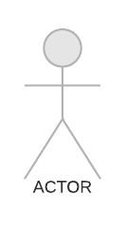

**Fig 6.3.1.2:** ActorName**.**

The Actor Name in our project is human whenever a human passes through Pir sensor this entire application is implemented.

**Power Source:**

Initially The DC Supply (5V) should be supplied to Raspberry Pi. The power source is dented as below:

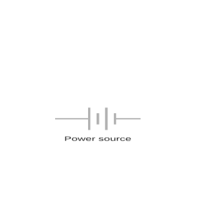

**Fig 6.3.1.3:** Power Source.

**Use-case:**

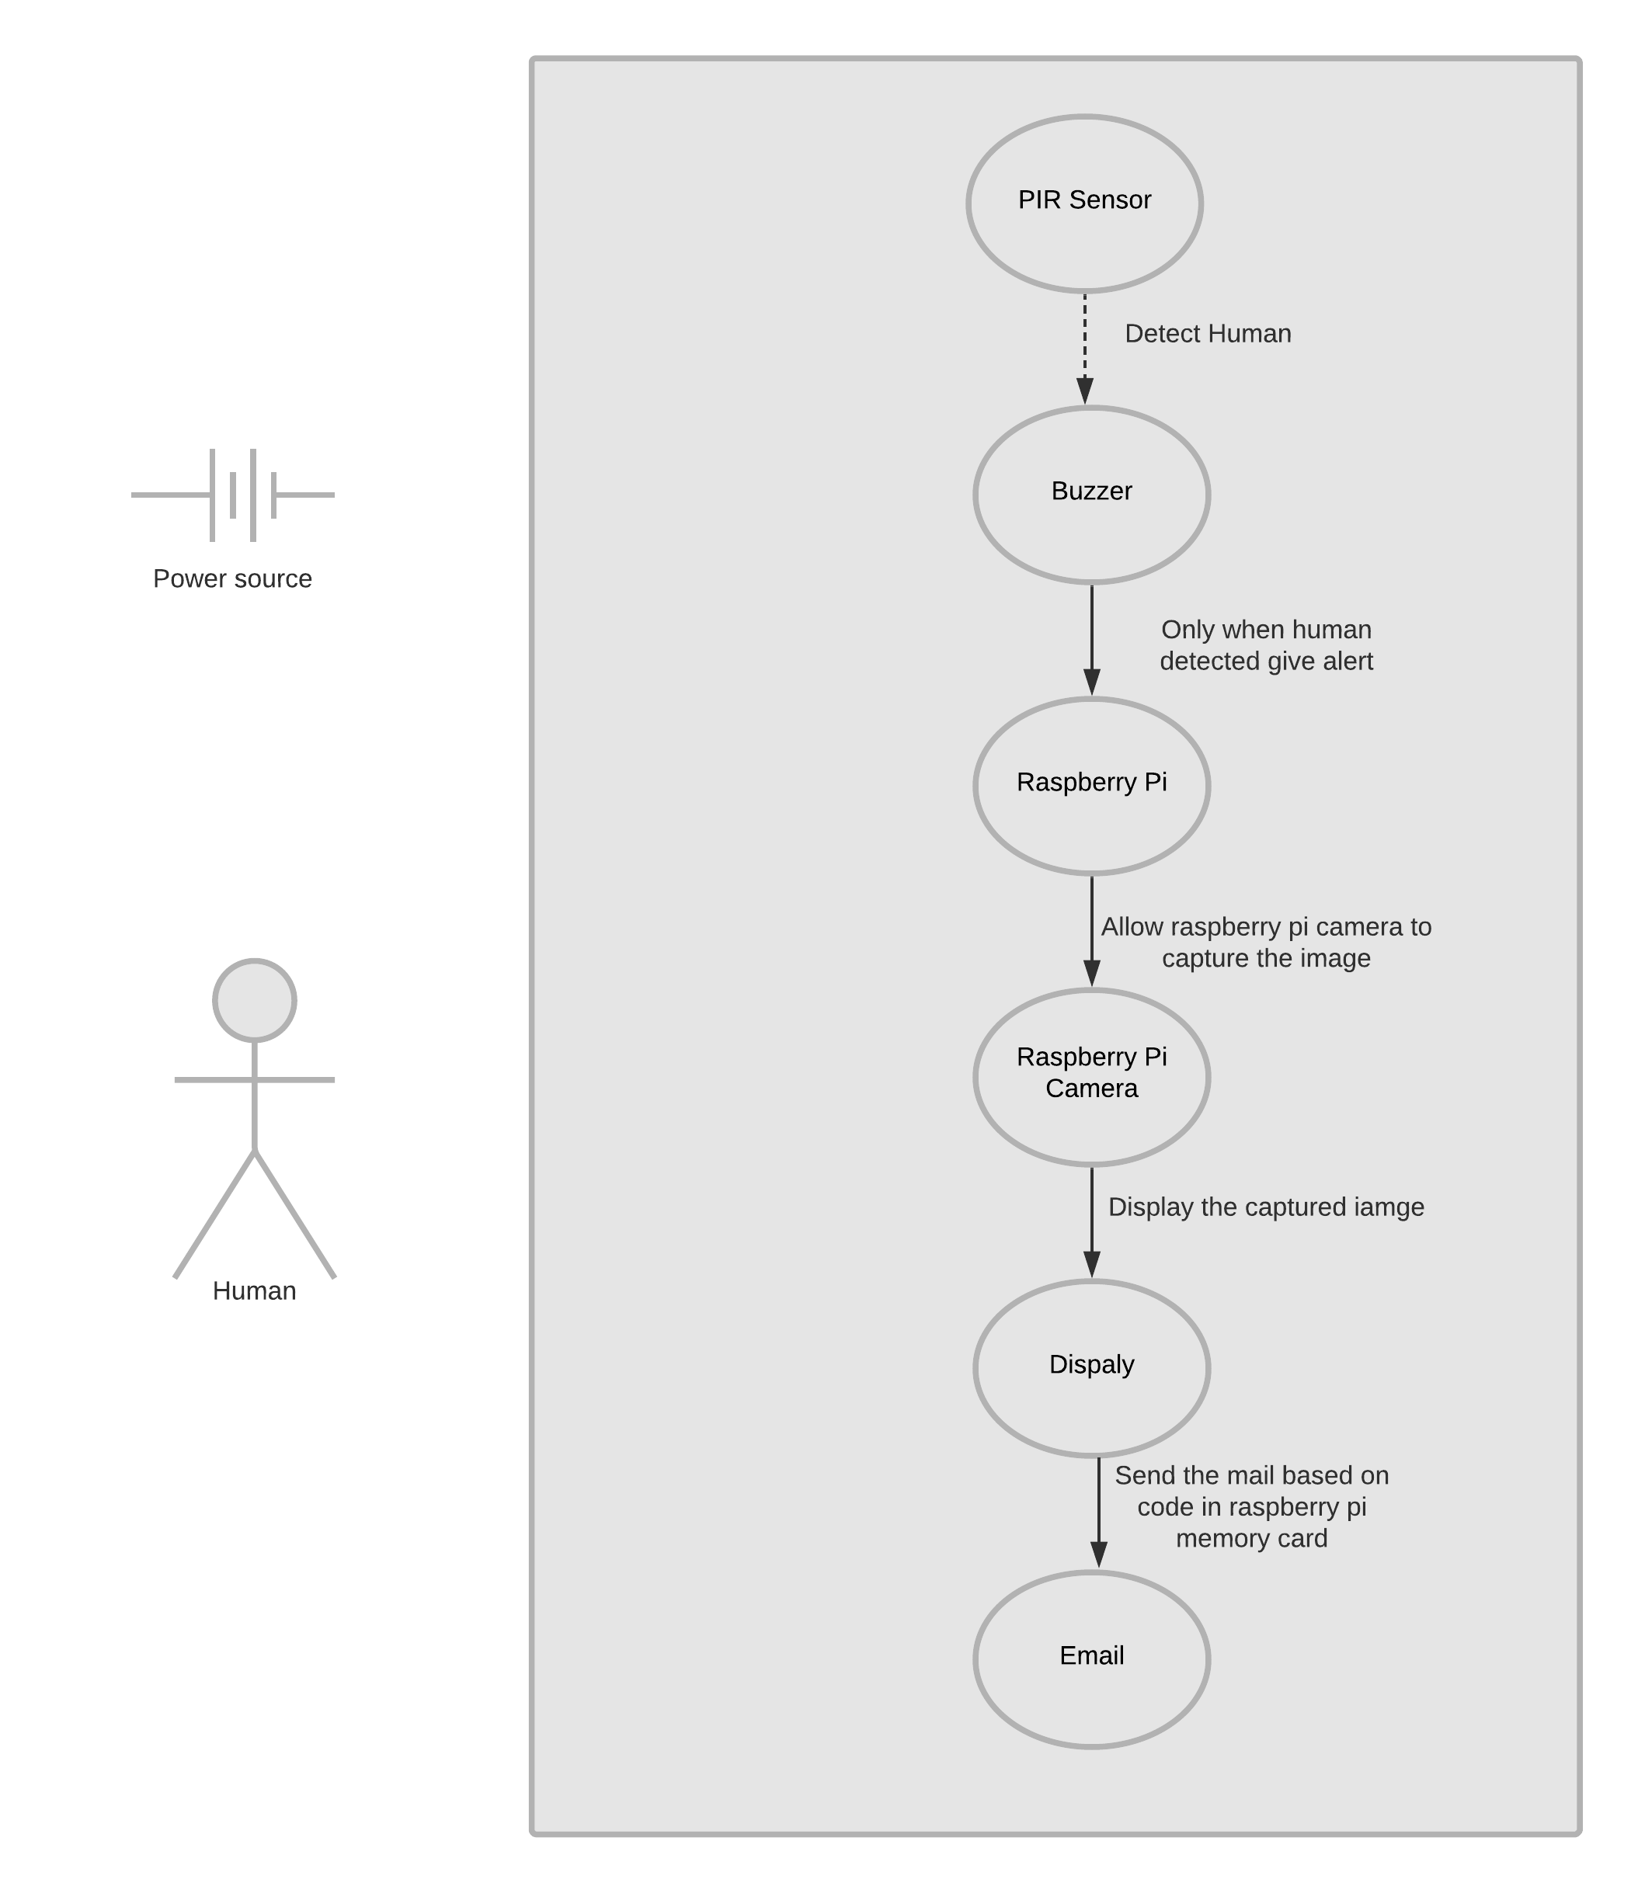

**Fig 6.3.1.4:** Use Case Scenario.

In 6.3.1.4, include notation is a dotted line beginning at base use case ending with an arrows pointing to the include use case.

In 6.3.1.4, straight line with arrow is [Generalization](https://www.uml-diagrams.org/generalization.html) between use cases is similar to generalization between classes – child use case inherits properties and behavior of the parent use case and may override the behavior of the parent.

**6.3.2 Sequence Diagram (Interaction Diagram)**

A sequence diagram represents the object interactions ordered in their time sequence. It is used to predict the order or sequence of messages interchanged among the objects that perform the functionalities of the scenario. Sequence diagrams are usually associated with use case realizations in the logical view of the system for development. Sequence diagrams may also be named as event diagrams/event scenarios. A sequence diagram has the following: different processes or objects that live simultaneously, parallel vertical lines, and they are connected by horizontal arrows, the messages interchanged among them, in the order in which they take place. This helps the specification of simple runtime scenarios in a graphical manner.

**Class role/Participants-**

The use of class roles is to tell how an object behavesin a situation. The UML object symbol can be used to illustrate class roles, but theydo not consider object attributes. The notation of class role is shown below:

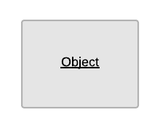

**Fig 6.3.2.1:** Class Role.

The Class Role Names that are used in our project are as follows:

* Pir Sensor.
* Raspberry Pi.
* Buzzer. Pi Camera.
* Display.
* Raspberry
* E-mail.

**Activation/Execution Occurrence:**

Activation boxes represent the time an object needs to complete a task. When an object is busy executing a process or waiting for a reply message, use a thin gray rectangle placed vertically on its lifeline. The Representation of Activation Occurrence is as below:



**Fig 6.3.2.2:** Activation Occurrence.

Each and every class role has its own Activation Occurrence that point out the relationship between the different class roles at each particular time.

**Actor:**

The actor is an entity that interacts with the system. A user is the best example of an actor. An actor is an entity that initiates the use case from outside the scope of a use case. It can be any element that can trigger an interaction with the use case. One actor can be associated with multiple use cases in the system.

The actor notation in UML is given below:



**Fig 6.3.2.3:** ActorName**.**

The Actor Name in our project is human whenever a human passes through Pir sensor this entire application is implemented.

**Power Source:**

Initially The DC Supply (5V) should be supplied to Raspberry Pi. The power source is dented as below:

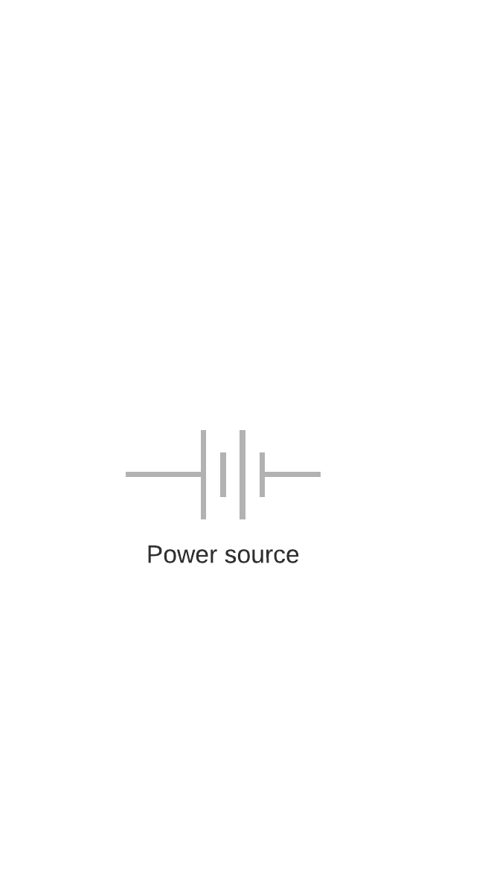

**Fig 6.3.2.4:** Power Source**.**

**Synchronous Message:**

A synchronous message requires a response before the interaction can continue. It's usually drawn using a line with a solid arrowhead pointing from one object to another.

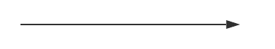

**Fig 6.3.2.5:** Synchronous Message**.**

Here, each and every activation occurrence is pointed to another one through synchronous message which contain the action as a form of a message performed between them at that point of time.

**Reply Message:**

The dashed lines indicate the reply message like link between the class roles is described.

**Sequence Diagram:**

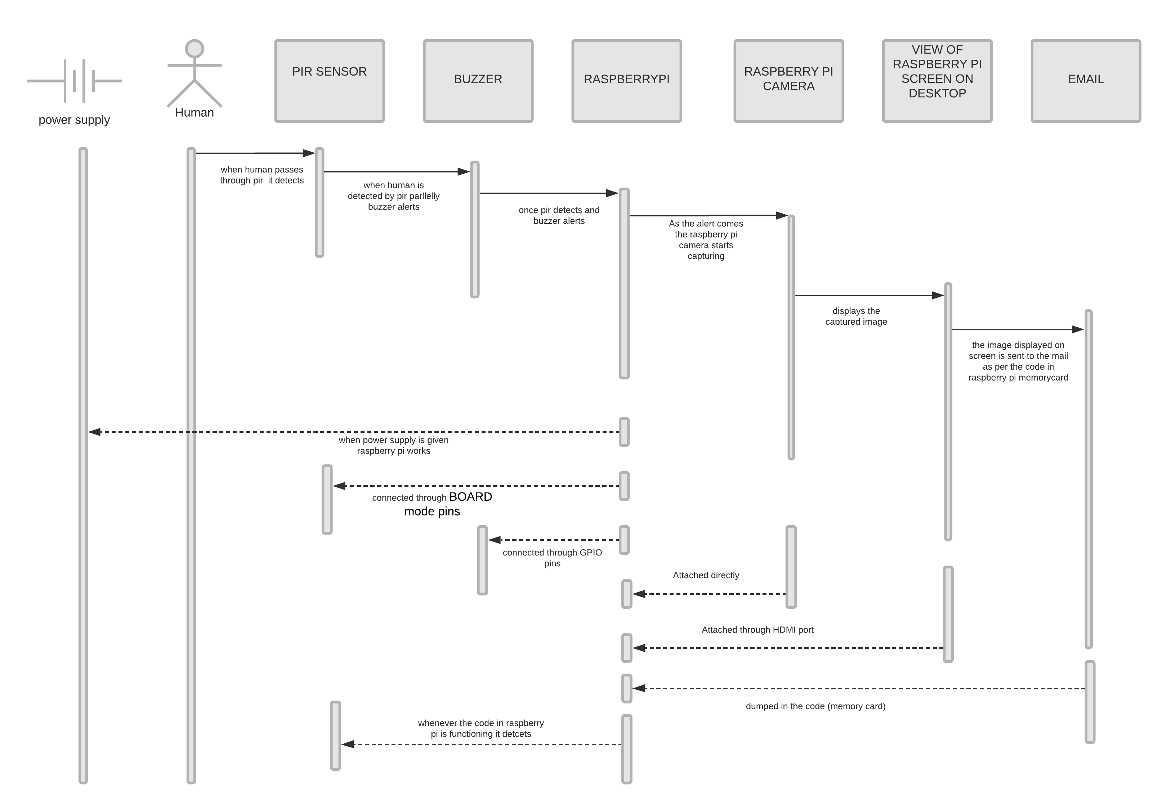

**Fig 6.3.2.6:** Sequence Scenario**.**

**6.3.3 Flowchart Diagram**

The flowchart represents the steps as boxes of different kinds, and they are connected by the boxes with arrows. This pictorial representation gives a solution model to the given [problem.](https://en.wikipedia.org/wiki/Problem_solving) Flowcharts are used to analyze, design, for documentation or for managing a process or program in different areas.

The table below explains the functioning and representation of each component in flowchart diagram:

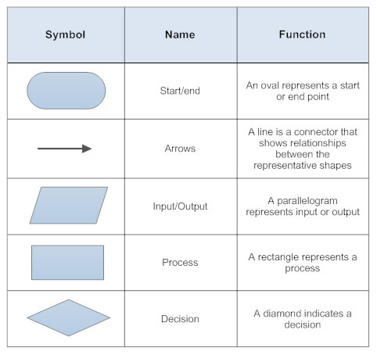

**Fig 6.3.3:** Components of flowchart**.**

When the power is supplied, the Pir sensor gets activated. If the human is not detected the flowchart executes NO condition i.e..,Pir sensor waits till the human is detected. If human is detected then flow chart executes the YES condition. Buzzer alerts with beep sound and Raspberry Pi allows the Raspberry Pi camera to capture the image. The captured image is displayed on the screen. As the image is displayed it is sent to the mail.

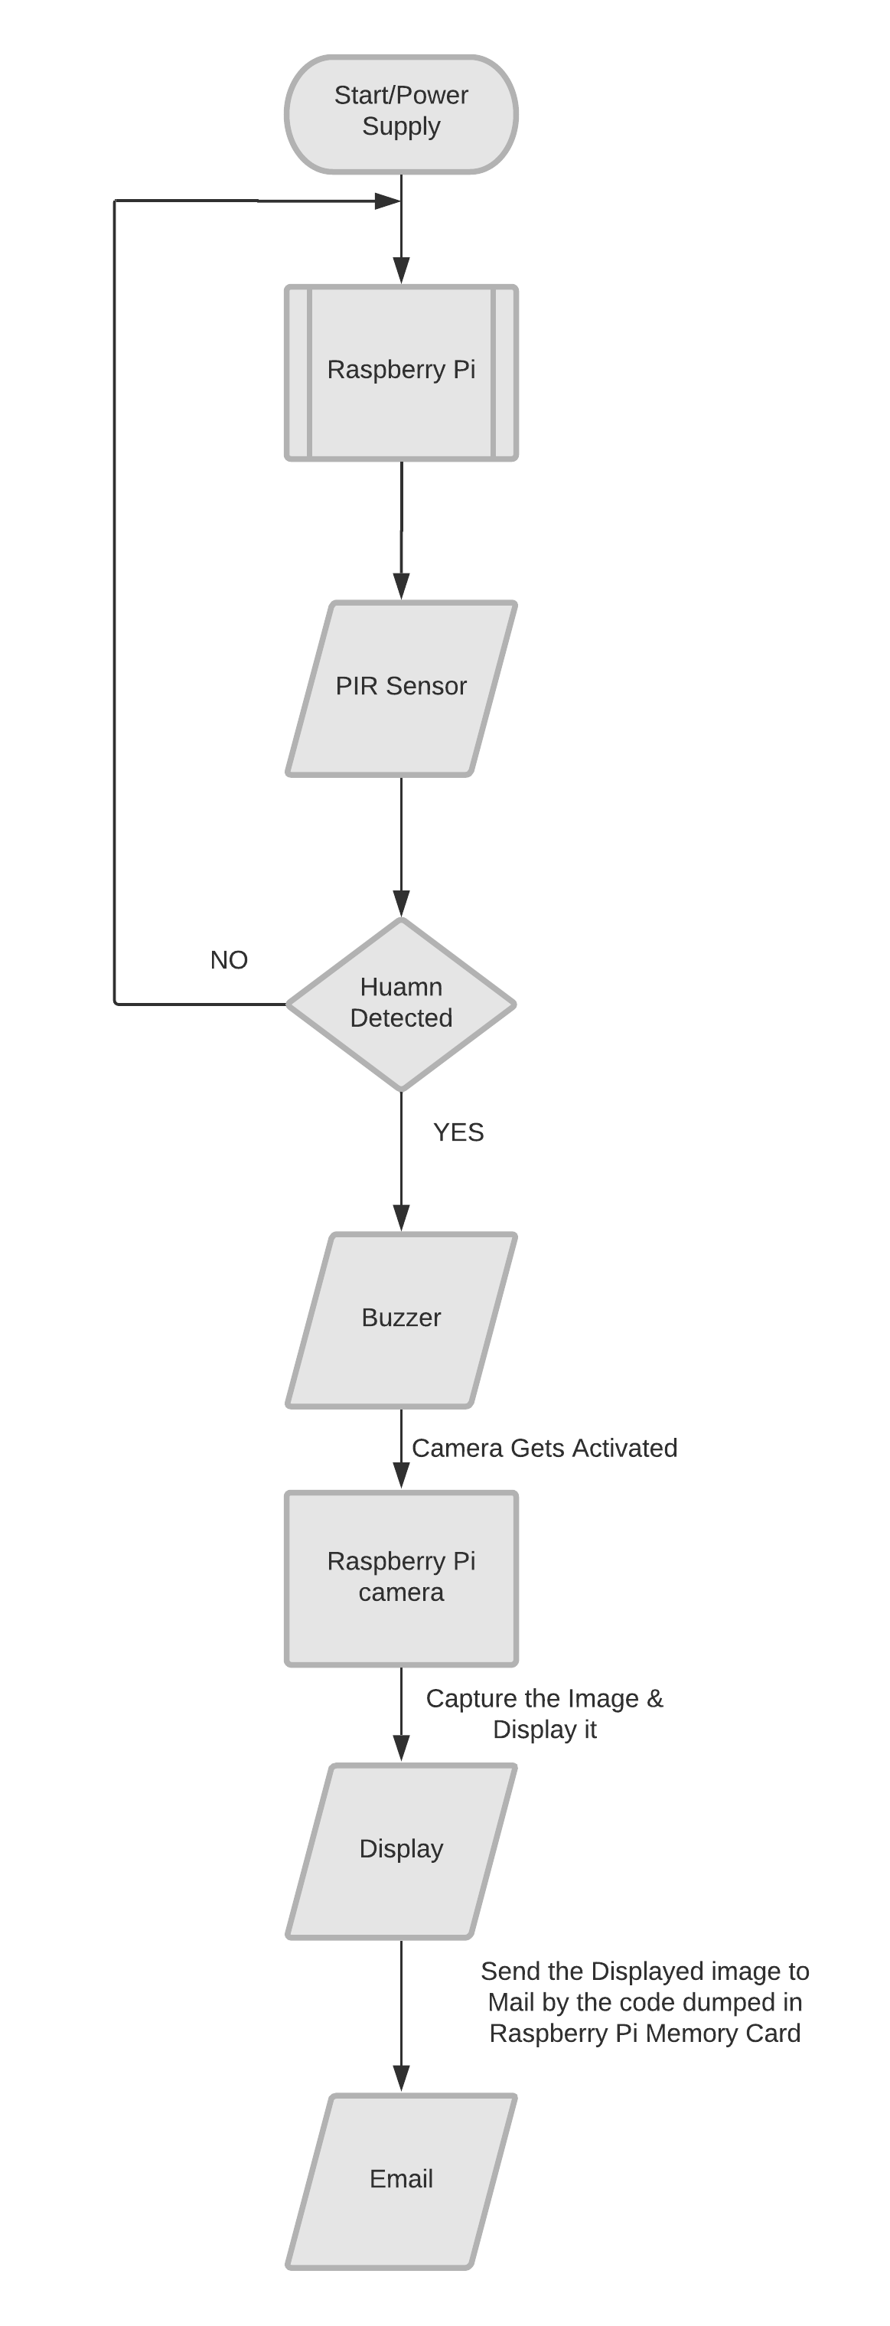

**Fig 6.3.3.1-** flowchart**.**

1. **CODING**

# Geany - The Flyweight IDE-Geany is a powerful, stable and lightweight programmer's text editor that provides tons of useful features without bogging down your workflow. It runs on Linux, Windows and has built-in support for more programming languages.

Visit The Site and Follow the steps To Install Geany in Raspberry Pi (Those steps need to be executed in command prompt of Raspberry Pi) <https://www.geany.org/download/third-party/>.

**Thonny** - It comes with Python 3.7 built in, so just one simple installer is needed and you're ready to learn programming. (You can also use a separate Python installation, if necessary.) The initial user interface is stripped of all features that may distract beginners.

Visit The Site and Follow the steps To Install Thonny in Raspberry Pi (Those steps need to be executed in command prompt of Raspberry Pi) <https://thonny.org/>.

* 1. **Coding For Human Detection Through PIR and sending mail:**

import RPi.GPIO as gpio # to access GPIO Pins from Raspberry Pi.

import picamera # to access the Raspberry camera.

import time # for waiting during execution of the code.

import smtplib # smtp protocol client(module to send mail and client interaction).

from email.MIMEMultipart import MIMEMultipart # intermediate base for messages.

from email.MIMEText import MIMEText # to create objects of major type texts.

from email.MIMEBase import MIMEBase # to specify subclasses of a message.

from email import encoders # flexible packaging and labeling equipment.

from email.mime.image import MIMEImage # to create objects of image types.

fromaddr = "vara.varaprasad9@gmail.com"

toaddr = [surakasulasrikavya@gmail.com](mailto:surakasulasrikavya@gmail.com)

mail = MIMEMultipart()

mail['From'] = fromaddr

mail['To'] = toaddr

mail['Subject'] = "Attachment"

body = "Please find the attachment"

buz=17

pir=18

HIGH=1

LOW=0

gpio.setwarnings(False)

gpio.setmode(gpio.BCM) # board com soc channel to describe pin number.

gpio.setup(buz, gpio.OUT) # initialize GPIO Pin as outputs.

gpio.setup(pir, gpio.IN) # initialize GPIO Pin as input

data=""

def sendMail(data):

mail.attach(MIMEText(body, 'plain'))

print (data)

dat='%s.jpg'%data

print (dat)

attachment = open(dat, 'rb') # rb means read binary.

image=MIMEImage(attachment.read())

attachment.close()

mail.attach(image)

server = smtplib.SMTP('smtp.gmail.com', 587) # send and route email between mail servers.

server.starttls() # tls-transport layer technique: protocol command to make the connection secure.

server.login(fromaddr, "8143805654amma1")

text = mail.as_string()

server.sendmail(fromaddr, toaddr, text

server.quit()

def capture_image():

data= time.strftime("%d_%b_%Y|%H:%M:%S") # %d-day of the month.

#%b-month as abbreviated.

#%Y-year.

#%H-hours (24-hour clock).

#%M-minutes.

#%S-seconds.

camera.start_preview()

time.sleep(5)

print (data)

camera.capture('%s.jpg'%data)

camera.stop_preview()

time.sleep(1)

sendMail(data)

gpio.output(buz , 0)

camera = picamera.PiCamera()

camera.rotation=180

camera.awb_mode= 'auto' # auto white balance(black and white color adjustments).

camera.brightness=55

while 1:

if gpio.input(pir)==1:

gpio.output(buz, HIGH ) #output digital HIGH on buzzer.

capture_image()

while(gpio.input(pir)==1):

time.sleep(1) #time delay of one second.

else:

gpio.output(buz, LOW) #output digital LOW on buzzer.

time.sleep(0.01) #time delay of 0.1 second.

* 1. **Installations of packages:**

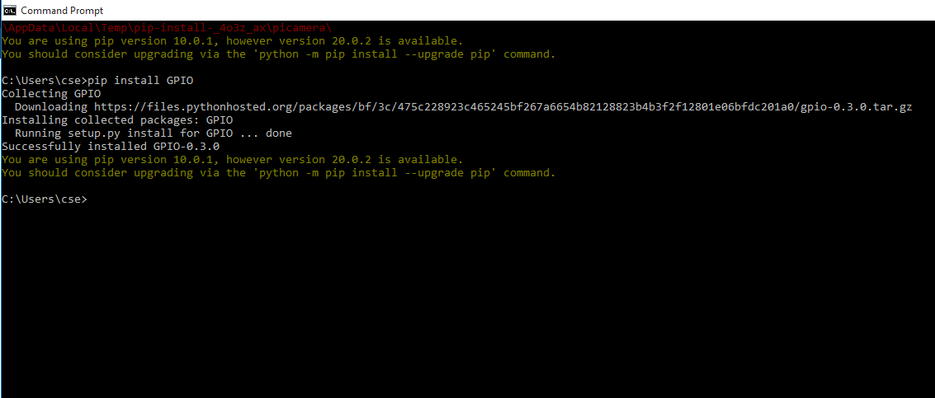

**Fig 7.2.1-** Installation of GPIO Package.

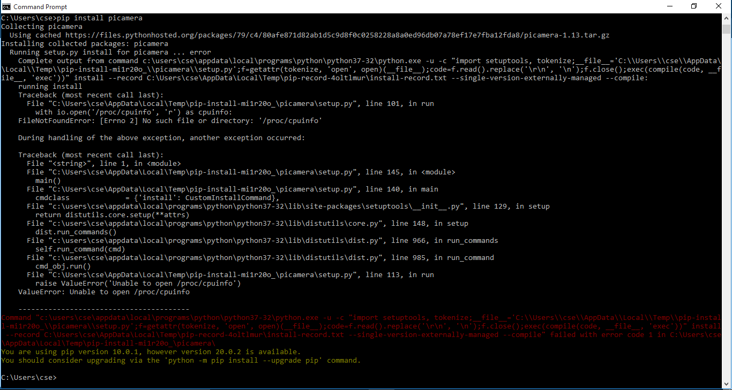

**Fig 7.2.2-** Installation of PiCamera Package.

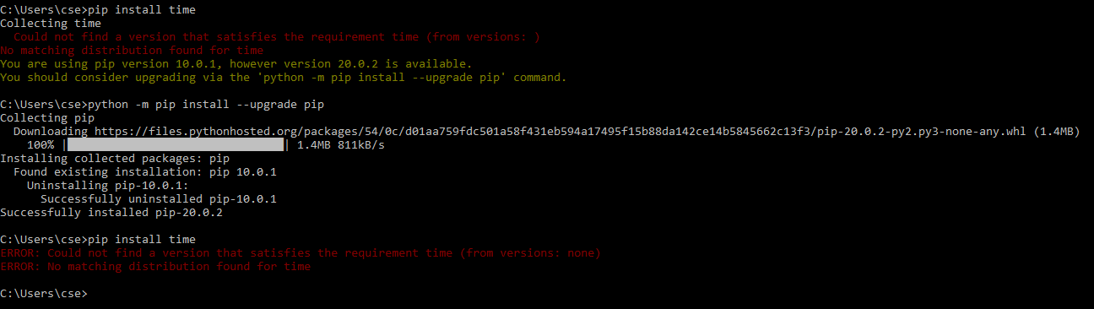

**Fig 7.2.3-** Installation of Time Package.

* 1. **View of Code in Raspberry Pi:**

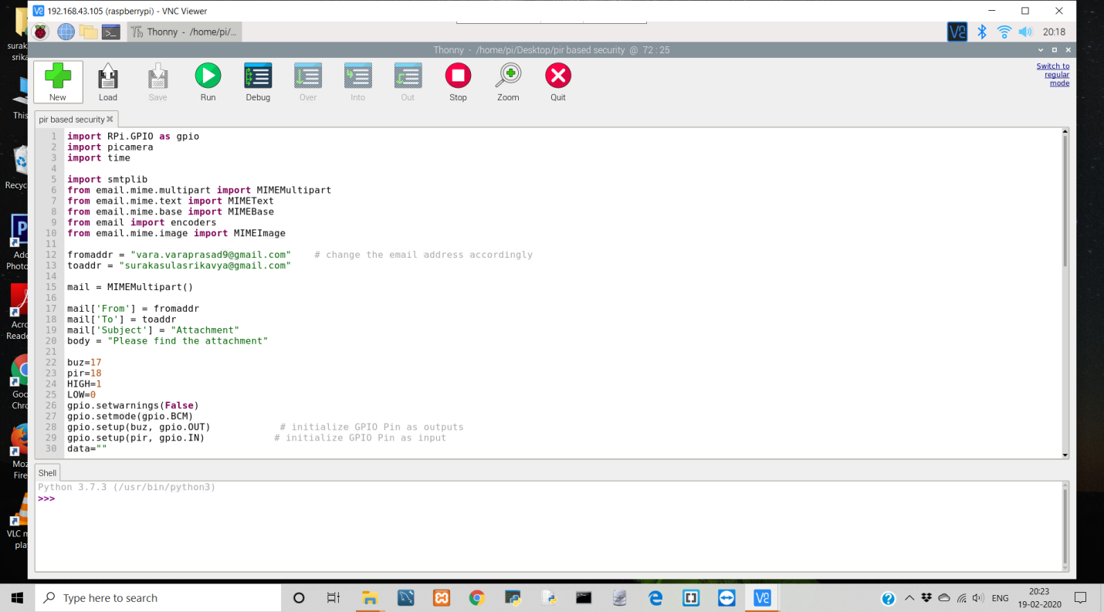

**Fig 7.3.1-** View of Code in Raspberry Pi Part-1.

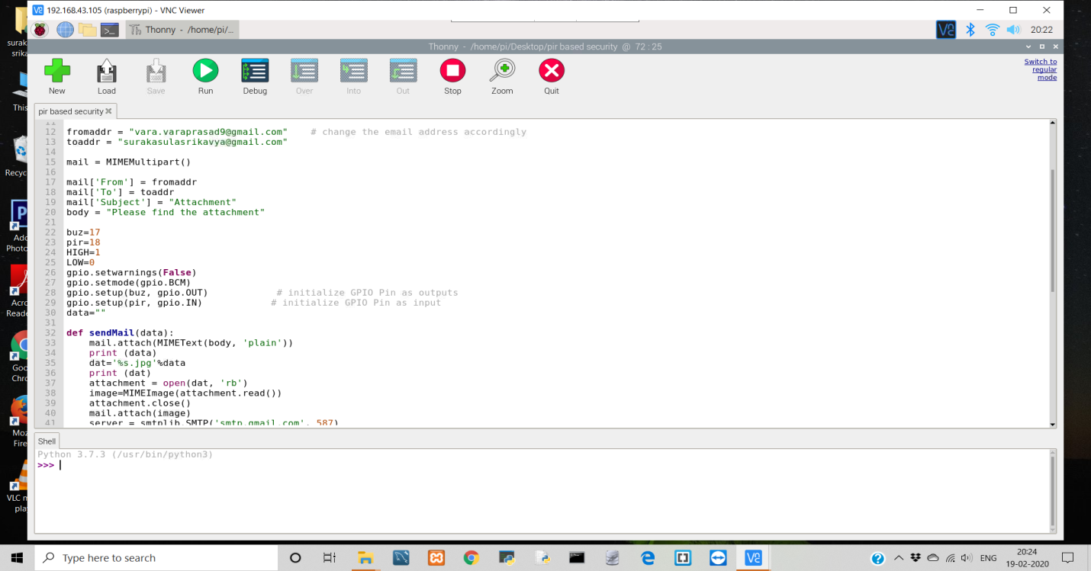

**Fig 7.3.2-** View of Code in Raspberry Pi Part-2.

1. **RESULT & DISCUSSIONS**
   1. **Functional Testing:**

A type of software testing in which the system gets tested against the functional requirements/specifications is called as functional testing.Functions (or features) are tested by giving the input and verifying the output. Functional testing makes sure that the requirements are completely satisfied by the application.

**Test Objectives:**

* Recognition of human through Pir.
* If human is recognized the buzzer beeps.
* The captured image should be sent to mail.

**Test Results:**

* Human is identified by capturing live image.
* Once human is recognized the buzzer beeps.
* Finally, The captured image should be sent to mail.
  1. **Non- Functional Testing:**

A type of Software testing that is used to check non-functional aspects like performance, usability, reliability, etc of a software application is called non-functional testing. It is designed to test whether the system is ready to satisfy all the non-functional parameters or not which are not addressed by functional testing.

**Test Objectives:**

* System must be responsive and user interface should look good.

**Test Results:**

* Interface looks good and application is very responsive.
  1. **Test Cases:**
* When no Humans pass through Pir.
* When a Human passes through Pir.
* When there are group of people pass through Pir.
* When there are objects but no Humans passing Through Pir.

**Test Case-1**

Expected Output: No buzzer beep alert, No E-mail.

Actual Output: No buzzer beep alert, No E-mail.

Result: Pass.

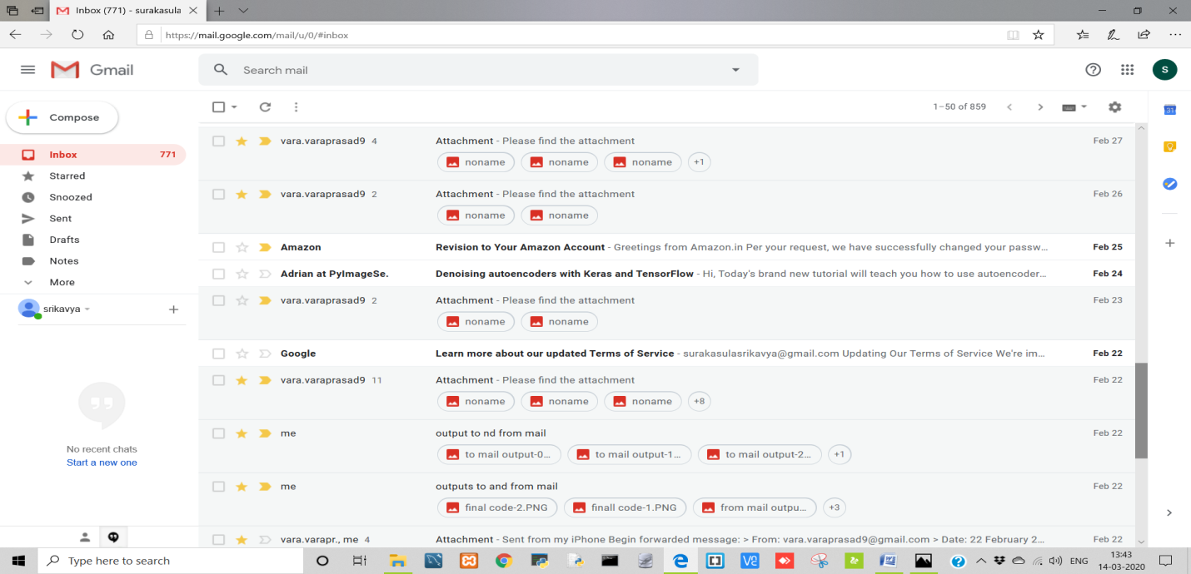

**Fig 8.3.1-** To E-Mail Output of test case-1.

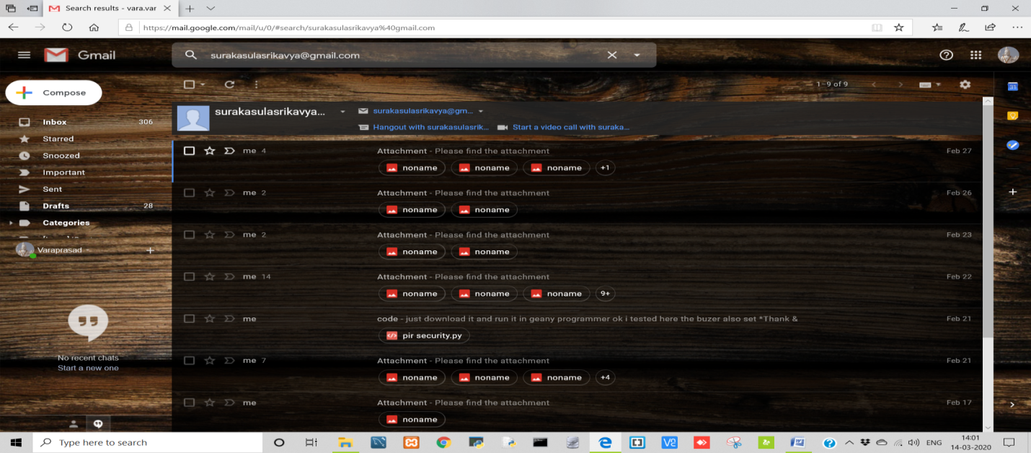

**Fig 8.3.1.1-** From E-Mail Output of test case-1

**Test Case-2**

Expected Output: buzzer beep alert, To receive E-mail attached with the captured image.

Actual Output: buzzer beep alert, To receive E-mail attached with the captured image.

Result: Pass.

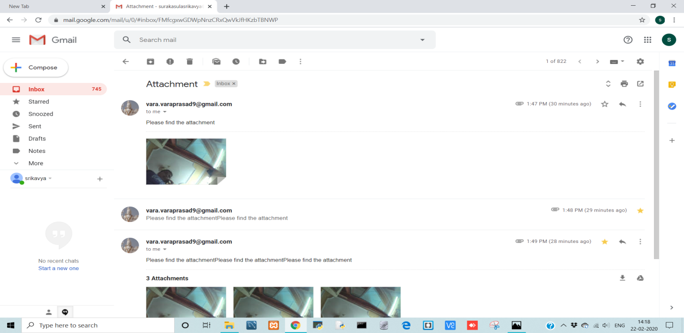**Fig 8.3.2-** To E-mail Output of test case-2.

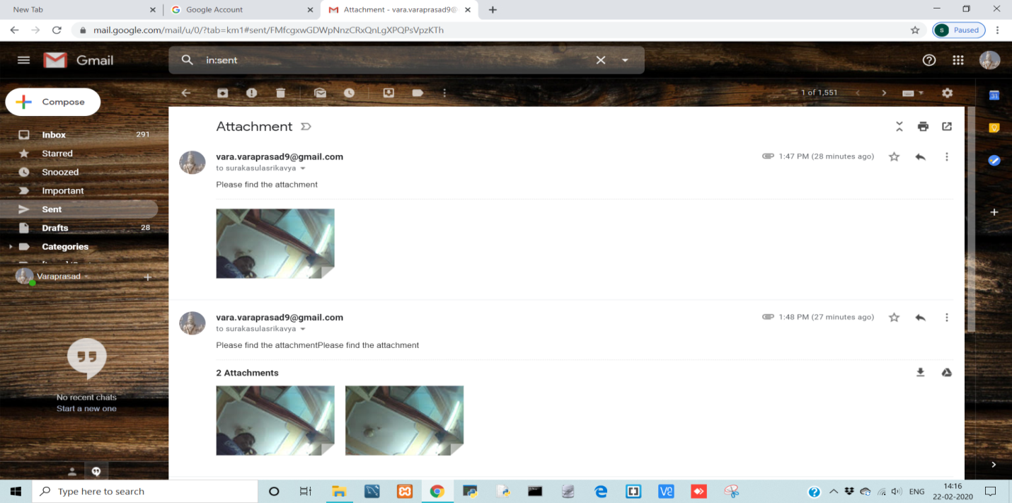**Fig 8.3.2.1-** From E-mail Output of test case-2.

**Test Case-3**

Expected Output: buzzer beep alert, To receive E-mail attached with the captured image.

Actual Output: Buzzer beep alert, To receive E-mail attached with the captured image.

Result: Pass.

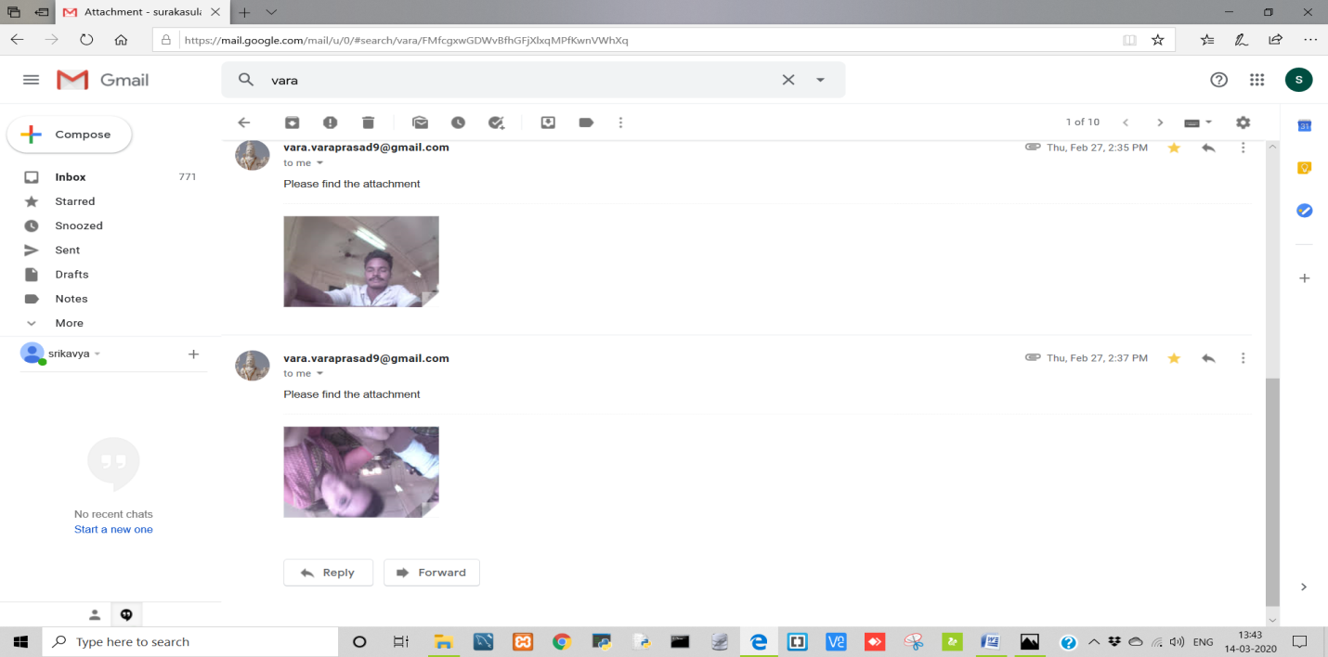

**Fig 8.3.3-** To E-mail Output of test case-3.

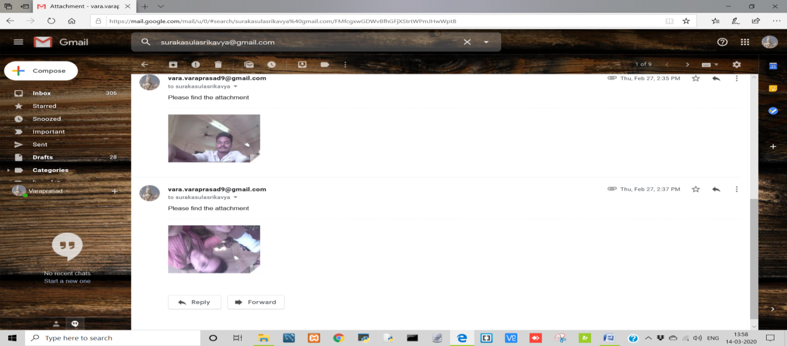

**Fig 8.3.3.1-** From E-mail Output of test case-3.

**Test Case-4**

Expected Output: No buzzer beep alert, No E-mail

Actual Output: No buzzer beep alert, No E-mail

Result: Pass.



**Fig 8.3.4-** To E-Mail Output of test case-4.

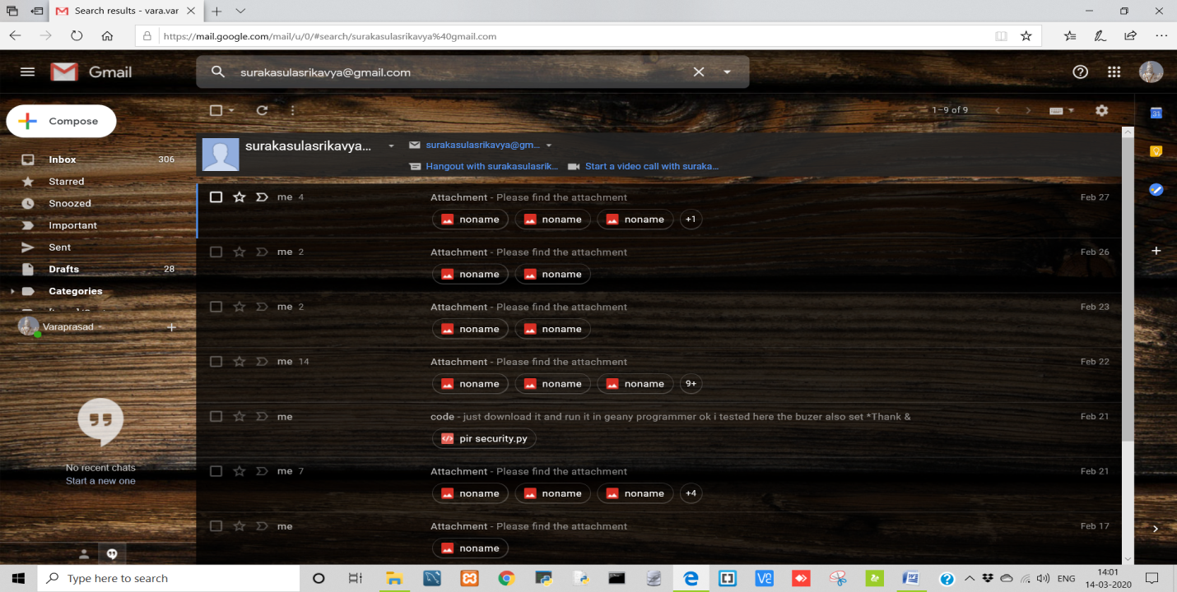

**Fig 8.3.4.1-** From E-Mail Output of test case-4.

* 1. **Format of the Image that is being sent to the E-mail:**

The received mail contains date and time when the picture is captured by Raspberry pi camera, along with its from address, to address and the subject of the mail (if the format of the picture is in the pdf form in the code that is dumped in memory card of Raspberry pi)

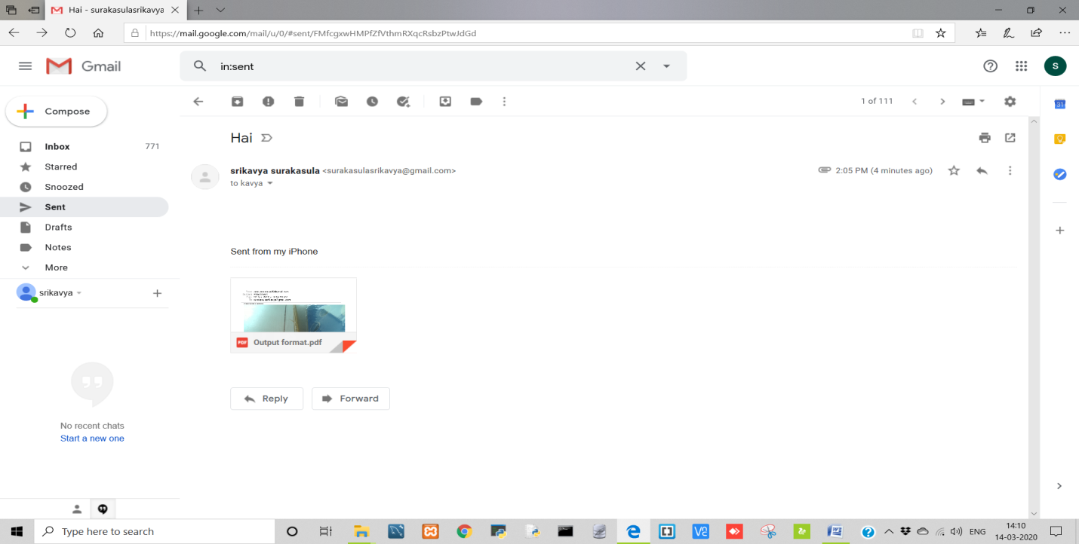

**Fig 8.4.1-** Output of pdf file.

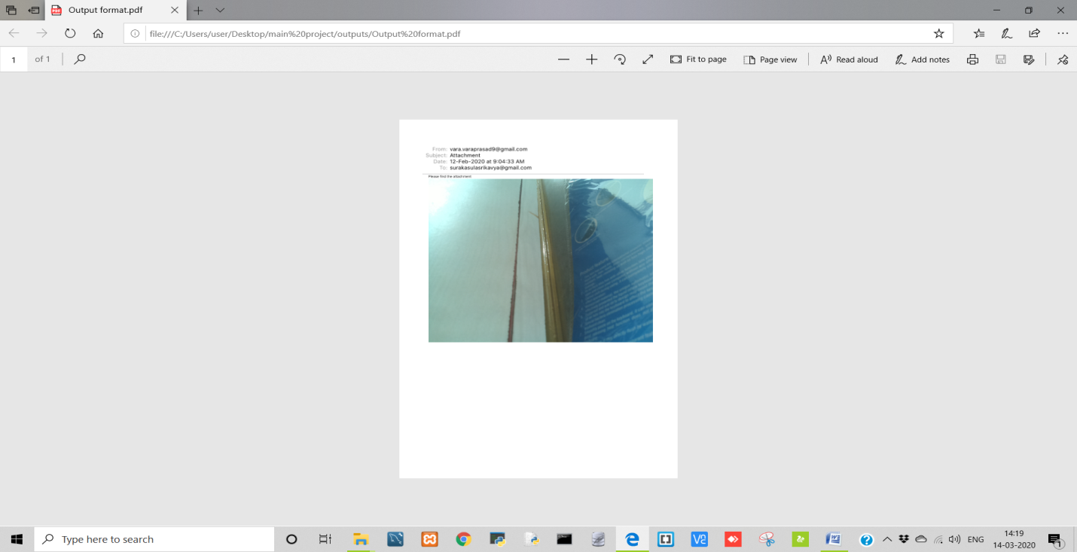

**Fig 8.4.1.1-** View of output pdf file.

1. **CONCLUSION AND FUTURE SCOPE**

Human detection technology has come a long way within the last twenty years. These days, machines areautomatically able to verify identity information for secure transactions, for surveillance and security tasks, and for access control to buildings etc. These applications usually need controlled environments and detection can cash in the environmental constraints to get high detection accuracy. However, next generation human detection systems would have widespread application in smart environments where computers and machines are more like helpful assistants.

To achieve these goal computers must be ready to accurately identify people in the surrounding in such a way that it matches naturally within the pattern of normal human interactions. They should not need special interactions and must confirm to human intuitions about when detection is probably going. This suggests that future smart environments should use the equivalent modality as humans, and have approximately the same disadvantages. These targets now appear in reach however, considerable research remains to be done in making human recognition technology to work accurately, in different conditions using information from single or multiple modality.

Today, one among the fields that use human detection the foremost is security. Human detection involves extremely effective tools which will help law enforcers recognize criminals and software companies are leveraging the technology to assist the users access their technology. This technology can be further developed to be utilized in other avenues such sensitive materials. This can be used to build other security constraints like passwords.

The project that has developed by us can be extended in future by adding some image matching algorithms;like in this project the captured human image is being sent to mail that photo is downloaded and viewed. Further scope is to collect all the downloaded images from the e-mail received and those images can be stored in a location(folder), and machine learning algorithms can be applied to these in order to identify who the person is and also to know how many times same person is passed in that particular area where this application isbuilt.

**10. REFERENCES**

Textbook-

* Simon Monk, Raspberry Pi cookbook: Software and Hardware Problems and solutions, 2/e-[**Simonmonk.org/raspberry-pi-cookbook-ed2**](http://simonmonk.org/raspberry-pi-cookbook-ed2/).

Research Papers-

* [Ishita Gupta](https://www.researchgate.net/scientific-contributions/2132253958_Ishita_Gupta), Varsha Patil, Sherya Kadam, *Face detection and recognition using raspberry Pi*, **2018.**

<https://www.researchgate.net/publication/335219198_FACE_DETECTION_AND_RECOGNITION_USING_RASPBERRY_PI-2018>.

* Ashwini Sinha, Face Detection Using Raspberry Pi, **2019.**

<https://www.electronicsforu.com/electronics-projects/face-recognition-using-raspberry-pi-2019>.

Related Papers-

* B Harish Kumar, *WSN based automatic Irrigation and security using Raspberry Pi Board,* **2017.**

<https://ieeexplore.ieee.org/search/searchresult.jsp?newsearch=true&queryText=raspberry%20pi%20with%20pir%20sensor>.

* S Sivakumar, Kumar M Ramesh, *Theft Detection system using PIR sensor,* **2016.**

<https://ieeexplore.ieee.org/xpl/conhome/7740393/proceeding>

* Ar Kar Kyaw, Hong Phat Truong, Justin Joseph, *Low-Cost computing using Raspberry Pi 2 Model B,* **2018.**

<https://www.engpaper.com/raspberry-pi-2018.htm>

* Nafis Mustakim, *Face Recognition system based on Raspberry Pi platform,* **2017.**

<https://www.academia.edu/41549558/Face_Recognition_System_Based_on_Raspberry_Pi_Platform>

* Hirankumar Gami *Movement direct ion and distance classification using PIR sensor,* **2018.**

<https://ieeexplore.ieee.org/document/8171774>